**Metabolic constraints drive the swarming diversity in pathogenic bacteria**

**Abstract**

Many species of bacteria have the incredible ability to form swarms and move cooperatively across surfaces. Swarming motility is important to the fitness and virulence of bacteria, yet strains of the same bacterial species vary widely: What underlies swarming diversity? Here we presented comparative analyses of genetics, metabolomics and growth curve data to investigate why 28 clinical *P. aeruginosa* strains isolated from different patients differ in their abilities to swarm and produce rhamnolipid—a necessary but not sufficient requirement for swarming. Despite the diversity of rhamnolipid production can be partially explained by the absence of quorum-sensing genes, the differentially expressed metabolites between rhamnolipid producing and non-producing strains suggest redox homeostasis as a more fundamental metabolic constraint. The increased oxidative stress in non-producers inhibited Fe-S containing enzymes such as the succinate dehydrogenase and resulted in reduced tricarboxylic acid (TCA) cycle activity and slower growth rate. Genome-scale model simulations and H2O2 detoxication experiments validate our theory on the links between growth, redox homeostasis and carbon overflow. Although the ability to direct excess carbon to the production of rhamnolipids is metabolically constrained at the individual level, it may be key to the evolution of *P. aeruginosa* swarming at the population level as rhamnolipids are public goods that help stabilize microbial cooperation. Our study also adds to the expanding literature on the observation that fast-growing bacteria enter overflow metabolism,

**Introduction**

Swarming motility is a flagella-driven movement of millions of bacterial cells to spread together over solid or semi-solid surfaces, and travel centimeter-long distances in a few hours (Deforet et al. 2014). The motility is narrowly conserved within certain bacterial species that are typically in the phyla Alpha-proteobacteria and Gamma-proteobacteria (Kearns 2010), suggesting that swarming is a complex phenotype that cannot be evolved by simply acquiring a few set of genes. The biological complexity of swarming is also reflected in the multi-scale nature of its underlying functional requirements, including flagellar or pili biosynthesis to propel forward, cell-cell interactions to maintain population integrity during migration, and collective secretion of biosurfactants as wetting agents to lubricate the surface and lower surface tension (Kearns 2010). Over the past two decades, considerable progress has been made in understanding the molecular mechanisms of swarming motility through genetic (e.g., knockouts, transgenesis) and environment (e.g., nutrient composition and viscosity of culture medium) perturbations (Köhler et al. 2000; Mattingly et al. 2018) as well as laboratory evolution (van Ditmarsch et al. 2013). Despite invaluable insights, these studies mainly focused on single genetic or environmental determinants but lack a systems-level understanding of the genetic and metabolic influences on the swarming phenotype (Kim and Surette 2004; Inoue et al. 2007). Indeed, the molecular functions of hundreds of swarming-associated genes span a wide range of cellular activities including tricarboxylic acid (TCA) cycle and stress response (Inoue et al. 2007; Tremblay and Déziel 2010), indicating that swarming is an emergent property that cannot be analyzed solely in terms of single genes or metabolic pathways.

Swarming bacteria are often associated with pathogenesis by showing enhanced antibiotic resistance and virulence (Overhage et al. 2008; Kearns 2010; Wang et al. 2004). *Pseudomonas aeruginosa*—an opportunistic human pathogen and a major cause of hospital infections (Klevens et al. 2007)—has remarkable swarming ability that produces long straight segments (tendrils) in its fractal-like swarming pattern. Similar to other swarming species, *P. aeruginosa* requires both flagella and pili to move, LasR-LasI and RhlR-RhlI quorum sensing systems to communicate within population, and rhamnolipid production to lubricate the surface (Köhler et al. 2000). Rhamnolipids are a mixture of biosurfactants that consist of 3-(3-hydroxyalkanoyloxy) alkanoic acids (HAAs), mono-rhamnolipids and di-rhamnolipids (Abdel-Mawgoud et al. 2010). RhlA is the only enzyme required to drive the conversion of fatty acid biosynthesis intermediates (β-hydroxyacyl-ACP) to HAA (Zhu and Rock 2008), whereas RhlB and RhlC each conjugates one molecule of rhamnose to HAAs to produce mono-rhamnolipids and di-rhamnolipids in sequential steps (Chong and Li 2017). The genes encoding RhlA and RhlB are located in the same operon *rhlAB*, which is regulated by the quorum-sensing cascade headed by LasR-LasI and followed by RhlR-RhlI (Medina et al. 2003). Other than quorum-sensing signals, *rhlAB* expression is also controlled by metabolic signals such as the presence of excess carbon in relative to metabolic capacity (Xavier et al. 2011; Boyle et al. 2015; Mellbye and Schuster 2014). The combination of quorum-sensing and metabolic signals prevent evolutionary exploitation of non-cooperative cheaters (e.g., an Δ*rhlA* mutant) by prudently ensuring that massive rhamnolipids are only produced at the right timing when the production benefits outweigh its costs, which would otherwise slows down growth and makes the cooperative trait susceptible to cheating (Xavier et al. 2011).

The metabolic prudence described above imposes one metabolic constraint on swarming. However, it remains generally unclear how cell metabolism informs the decision of swarming and what are other constraints that prevent swarming when violated. Since metabolism is the currency of all physiological processes that support life (Smith and Morowitz 2004) and a major determinant of social behavior such as swarming (Biro and Stamps 2010), searching for other metabolic constraints can help elucidate the principles of social behavior evolution by natural selection and uncover the links between individual-level processes and population-level fitness. Deletion of *rhlA* gene, which abolishes rhamnolipid production and swarming, had only minimal effects on cell metabolism (~10 intracellular metabolites were perturbed) (Boyle et al. 2017) Indirect perturbations of cell metabolism, such as changing carbon and nitrogen sources (Köhler et al. 2000) or antibiotic treatment (Bru et al. 2019), reveal intimate links between swarming and certain metabolic pathways. Direct perturbations through global metabolic network could not only abolish swarming but devastate metabolic homeostasis with major changes in the intracellular metabolome. For example, mutations in the gene *cbrA*—a global regulator that modulates carbon-nitrogen balance, virulence and antibiotic resistance (Yeung et al. 2011)—impaired swarming, reduced growth rate of *P. aeruginosa*, and disrupted metabolism by altering dozens of intracellular metabolites (Boyle et al. 2017). Notably, the *ΔcbrA* mutant still had the necessary flagella to swim and expressed even more rhamnolipids than its parent wild-type strain. More interestingly, the swarming phenotype can be rescued by compensatory point mutations in the RNA chaperone *hfq* through rewiring of metabolic network to reconstruct a unique metabolome which was distinct from both the Δ*cbrA* and the wild-type (Boyle et al. 2017).

To discover new metabolic constraints of *P. aeruginosa* swarming, we collected a panel of 28 clinical strains isolated from hospitalized cancer patients in Memorial Sloan-Kettering Cancer Center (MSKCC) (Yan et al. 2017; Yan et al. 2019), which vary widely in their ability to swarm and to produce rhamnolipids. Compared to laboratory-evolved strains, the main advantage of using clinical isolates is that they were evolved in many body sites of different patients and thus more likely to generate swarming diversity at both phenotypic and genetic levels. Indeed, these clinical isolates constitute a wide range of swarming phenotypes, including 8 strains that neither swarm nor produce rhamnolipids. The phylogenetic relatedness of core genomes were unable to explain the observed diversity of swarming and rhamnolipid production, which can be partially explained by the loss of quorum-sensing genes in the accessory genomes. Using metabolomics and growth curve data acquired in the liquid culture with glycerol as the sole carbon source, we show more fundamental characteristics associated with the non-producers of rhamnolipids such as reduced tricarboxylic acid (TCA) cycle activity and slower growth, which are presumably caused by accumulated reactive oxygen species (ROS) and increased oxidative stress. With mathematical modeling and independent validation experiments, we provide strong evidences that rhamnolipid production is constrained by redox homeostasis with rhamnolipid producers more capable of detoxifying ROS produced by energy metabolism and particularly the TCA cycle. Our theory revealed the links between growth, redox homeostasis and carbon overflow, adding to the expanding literature on the studies of mechanistic explanation and evolution of bacterial overflow metabolism.

**Results**

**Swarming diversity is uncorrelated with phylogeny of core genomes**

Swarming colonies in the casamino-acid agar plate (see Methods) showed markedly different morphological shapes across the 28 clinical isolates, with a half of strains unable to swarm and a few strong swamers (Fig. 1). To quantify the swarming morphology, we used image analysis (see Methods) to measure five morphological features, including the swarming area (the percentage of the plate occupied by the colony), the maximum length (maximum diagonal of the rectangle fitting the colony), the circularity, the eccentricity and the length of a skeleton obtained from the image. A principal component analysis revealed that the maximum length and circularity of the colonies are the two features that best describe the diversity of swarming shapes (Supplementary. Fig. S1). By defining a swarming score as a linear combination of the two features (see Methods), we show that swarming does not correlate with phylogeny of the core genomes nor with the tissue of origin of each isolate (Moran’s I test, p-value=0.93). Since production of rhamnolipids is required for swarming motility, we further measured rhamnolipid production using a drop collapse assay (see Methods) in a synthetic media with glycerol as the sole carbon source and provided in excess for rhamnolipid production (Boyle et al. 2015). As expected, all strains able to swarm produced rhamnolipids but rhamnolipid producers may not swarm, confirming that rhamnolipid production is a necessary but not sufficient requirement for swarming. Similar to swarming, rhamnolipid production is also uncorrelated with phylogeny (Fig. 1B**,** Moran’s I test, p=0.14).

How do rhamnolipid production and swarming evolve in the lineage of clinical isolates? To fully understand the evolutionary relationship of the two phenotypes, we built an evolutionary model to reconstruct on the phylogenetic tree their ancestral states (see Methods and Supplementary Figure S2). The common ancestor of all the strains can both swarm and produce rhamnolipids, suggesting loss of functions in evolution. Compared to swarming, rhamnolipid production is more evolutionarily conserved and its functional loss occurs more recently, as the immediate ancestors of all isolates that do not produce rhamnolipids are rhamnolipids producers. By contrast, the loss of swarming motility occurs earlier in the phylogenetic tree, which agrees with the fact that swarming depends on other factors than rhamnolipid production.

**Swarming diversity is partially explained by the loss of quorum-sensing genes**

Since the core genomes were unable to explain swarming diversity, we studied the role of accessory genomes, particularly those genes that are missing only in rhamnolipids non-producers (Table 1). Notably, genes encoding rhamnolipid production pathways (*rhlA*, *rhlB*, *rhlC*) are intact in all non-producers. However, we found that F63912, W36662 and W60856 lose quorum-sensing genes (*lasR*, *rhlR*, *rhlI*), all of which have been confirmed as swarming regulators in previous experiments (Köhler et al. 2000). The

we found that For the three worst growing strains, M1608 and F5677 have the most missing genes; although M55212 only misses two genes, those two, named *crc* and *rph*, are essential for carbon catabolism and tRNA processing (ref). For another three rhamnolipids non-producers, F63912, W36662 and W60856, they all lose quorum sensing regulators, which indicates that even cell density is high, rhamnolipids may not be properly produced. For the last two isolates that do not produce rhamnolipids, S86968 does not have *pdxA*, the gene coding for enzyme catalyze NAD(P) to NAD(P)H and *hcnABC* which forms a membrane-bound flavoenzyme that involves electron transferring, and H27930 misses *pcd*, a gene predicted to code for oxidoreductase that reduces NAD(P). All the eight strains that do not produce rhamnolipids in the glycerol medium, they miss genes coding for either density regulation or for carbon/energy processing, indicating a deep link to cell growth. Therefore we next use quantitative modeling to disentangle growth features that could be used to predict rhamnolipids production.

|  |  |
| --- | --- |
| **Non-producers** | **Missing genes** |
| **F5677** | *arsB, arsC, arsH, arsR, chiC, dacB, fliM, gcd, qscR, gntK, gntR, ilvA1, kdsB, pbpC, pchA, phzA2, soxR* |
| **F63912** | *lasR* |
| **H27930** | *arnA, pelA, pcaB, pcaD, pfeA, icmF3, rrsmE, pcd, pirR, pctA, pctB, osmE* |
| **M1608** | *tauD, opdG, pdxA, hcnC, hcnB, hcnA, glgA, ybhO, glgB, katE, glgP, ligD, ada, opdO, kynB, fusA2, cynR, cynT, cynS, cmrA, gor, galU, amrB, gnyD, gnyB, gnyH, gnyA, gnyL, hmgA, fahA, maiA, bdhA, atoB, scoB, ppiC1, pqqD, pqqC, pqqB, exaC, exaB, exaA, pqqF, braZ, rbsK, rbsR, rbsC, rbsA, rbsB, pcd* |
| **M55212** | *crc, rph* |
| **S86968** | *kdsB, cysP, hcnC, hcnB, hcnA, pdxA, opdG, nfxB, cupB3* |
| **W36662** | *rhlR, rhlI, cupC1, pilC, pilS* |
| **W60856** | *lasR, pirA* |

Table 1 Genes that are missing in non-rhamnolipid-producers but present in all producers

**Rhamnolipid producers are fast-growing strains**

Rhamnolipids production is not activated unless there is extra carbon, which resembles overflow metabolism, a mechanism that is generally associated with fast growth of bacteria when there is a high level of glucose as the carbon source. To test whether this association remains valid for rhamnolipid production, we . compared the growth curves of the rhamnolipid producers (orange lines) largely overlap with the non-producers (blue lines) and the differences between the two groups are not visually apparent (Fig. 2A). To explore whether rhamnolipid production can be characterized by local features of these growth curves, we adopted both unsupervised and supervised learning approaches to extract the local features and test such association. For the unsupervised approach, we used a non-negative matrix decomposition method which approximates each growth curve as a weighted sum of three basic functions (features). Notably, there is a significant difference in the weights associated with Basis 1 between the two groups (Fig. 2B), suggesting the existence of an association between rhamnolipid production and bacterial growth. To identify an interpretable feature with which rhamnolipid production is mostly associated, we divided each growth curve into three phases based on its shape and defined 7 quantitative features to characterize each phase (Fig. 2C). Using Random Forest classification, we found that the top two features with the highest importance score is the maximum specific growth rate and the average growth rate in phase 1 (exponential phase). This finding reveals that rhamnolipid producers are also fast-growers, consistent with the common observation that fast-growing bacteria can secret the extra carbon into the environment.

**Swarmers (Rhamnolipids producers) have similar metabolomes**

Is there any general strategy that the *P. aeruginosa* rhamnolipids producers use to keep fast growth? We try to answer this question by comparing the intracellular metabolome of between producer and non-producers when they approached the end of exponential growth as well as the beginning of rhamnolipids production in glycerol medium. After extraction and profiling using liquid-chromatography coupled to mass spectrometry (LC-MS), we identified a total of 99 compounds (**Fig. 3A**), and from these we chose 70 compounds that passed several criteria for further analysis ( materials and methods). Strains M55212 and F23197 do not have metabolomic data because they grew too slow. We included strain M6075, which was not in our phylogenetic assay due to unsatisfactory genomic sequencing and assembly. We again use hierarchical clustering analysis to profile our metabolomics data (**Fig. 3B**).

Every strain was measured in three technical replicates. All the replicates clustered together except for one replicate of strain H47921 (sample 25) (Fig. 3B) ,which was removed from further analysis. The clustering revealed three major groups of metabolomic patterns. Interestingly, the strains with high swarm scores were assigned to the same cluster, suggesting a strong link between swarming and the intracellular metabolome. Our finding supports previous observation that the swarming, a social behavior of bacteria, is closely linked to intracellular metabolism (Boyle et al. 2017). Regarding rhamnolipid production, four out of the six rhamnolipid non-producers clustered in the same subgroup. However we don’t see an obvious pattern of metabolites in rhamnolipids producers. To identify the intracellular compounds that separate rhamnolipids producers and nonproducers, we turned to a supervised approach.

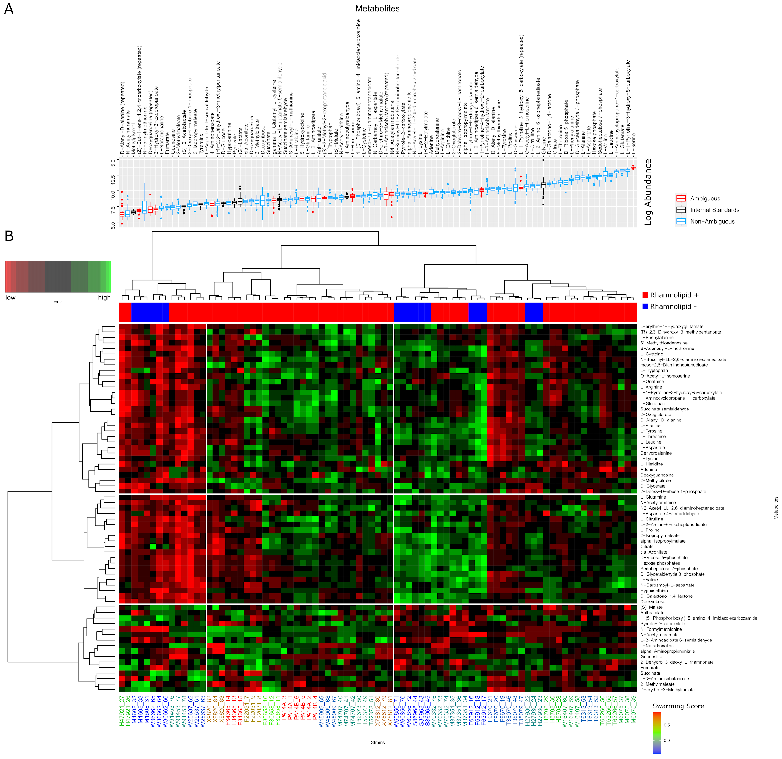

**Figure 3.** A. Levels of all the metabolites identified by LC-MS. The values shown here are absolute pre-normalization of all the compounds in the uncurated metabolite table (logarithm of the peak area) used for the HCA normalization. The blue-coded metabolites had a non-ambiguous peak identification. The black-coded metabolites were used as Internal Standard in the Cross-Contribution Compensating Multiple Standard Normalization. These were assumed to be constant across strains by a Kruskal-Wallis test and a level of significance of 0.05 (after Benjamini-Hochberg *p-*value correction). The red-coded metabolites were removed after the HCA because of uncertain identity. Many metabolites were renamed during the curation, producing some duplicated names, which are labeled as “repeated”, and were removed. B.Hierarchical Cluster Analysis of the metabolic profiles.The intracellular metabolites measured for each strain show that swarmers have similar metabolic profiles. The metabolic profile of each strain was determined by LC-MS and normalized with CCMN method. 3 replicates were done for each strain. This heatmap is only showing the compounds that the experimentalists were confident about their identity. The data was clustered using Euclidean distance and Ward D aggregation method. The swarming behavior of each strain is color coded. The high swarmers are red-coded and low swarmers blue coded. The strains that swarm better appear all grouped in the same sector. F30658, which is a mild swarmer, is the only swarmer strain that is not grouped to the other ones. Regarding the metabolites, some sectors of the heatmap are higher in some groups of strains, but there is not any obvious pattern differentiating the strains with high swarming score.

**Amino acid metabolism and TCA cycle are perturbed in rhamnolipid non-producers.**

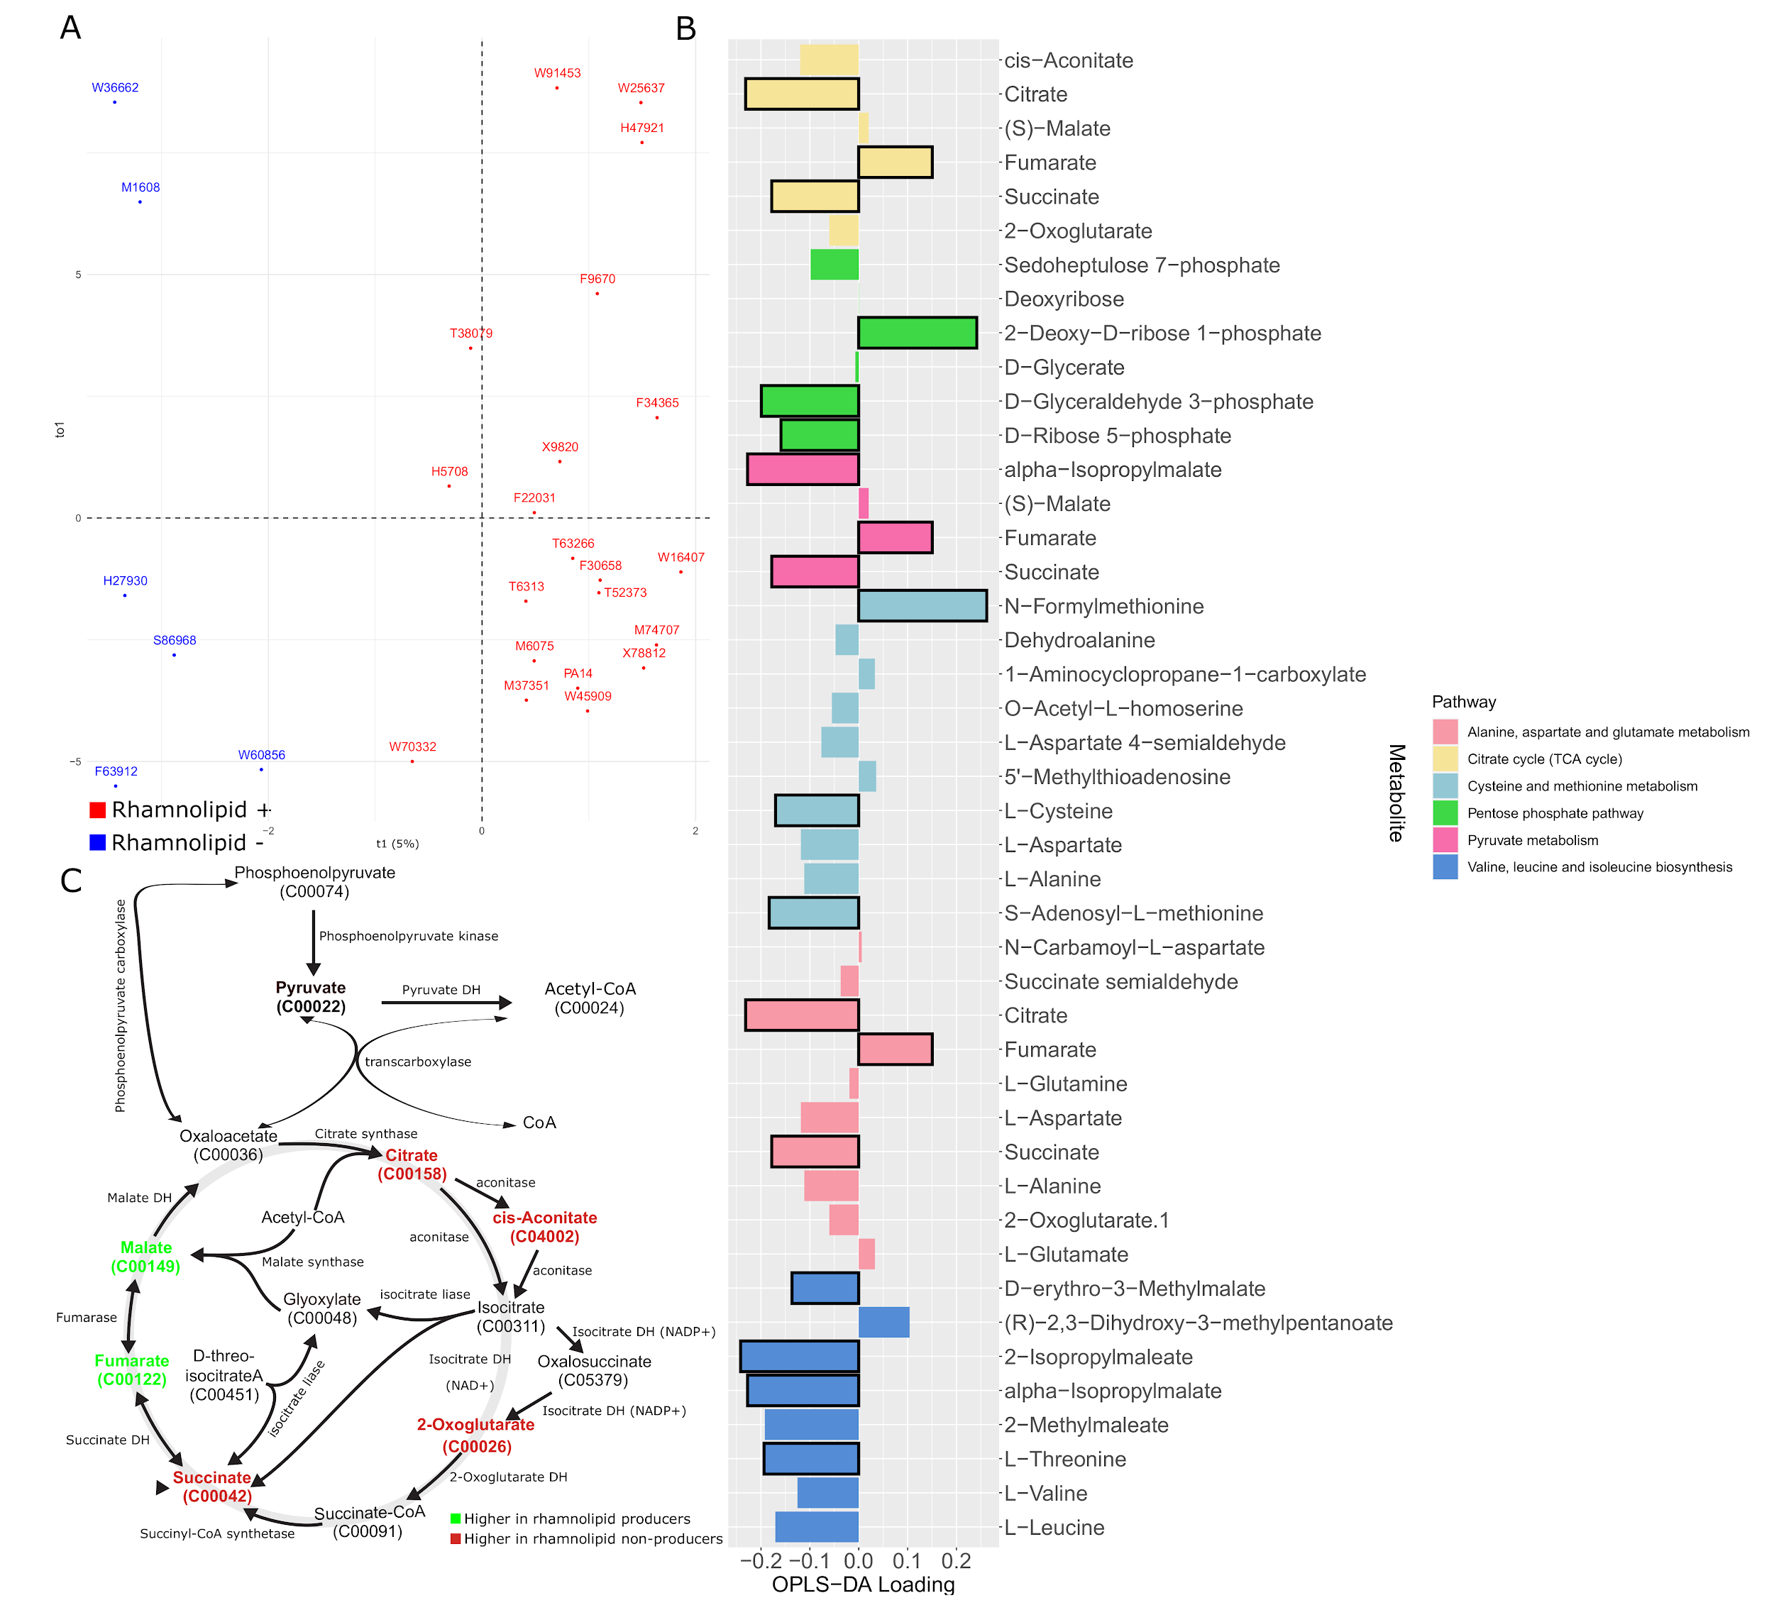

**Figure 4.** A. Score plot of the OPLS model. The strains appear separated according to whether they produce or not rhamnolipids across the predictor component (t1). B. Loading values for the predictor component of a selected number of metabolites, mapped to the pathways they are involved in according to KEGG database, among the ones found to be potentially altered according to FELLA algorithm. C. TCA Cycle map. The compounds that are in our metabolomic dataset appear in bold. The colored ones are the ones that are correlated to any of the rhamnolipid production phenotypes. Pyruvate does not appear in B because it was found to be constant, so it was removed in the normalization step.

To identify the metabolites that are correlated to rhamnolipid production in our clinical isolates we fitted our metabolomic data to rhamnolipids production phenotype using Orthogonal Projections to Latent Structures Discriminant Analysis (OPLS-DA) (Fig 4) [Trygg and World 2002]. The output model (t1) can separate the strains according to whether they produce rhamnolipids or not with good fit (R2 = 0.822, Q2 = 0.664, *p-*value = 5e-4) (Fig. 4A), explaining 5% of the variance, meaning that rhamnolipid producers and non-producers groups are heterogeneous (95% of the variance of the data is orthogonal to the predictor component), which explains why it is difficult to identify the compound using unsupervised method. To identify pathways that are different between rhamnolipids producers and non-producers, we performed a metabolic pathway enrichment analysis using FELLA [Picart-Armada 2018 doi: 10.1186/s12859-018-2487-5] with a univariate analysis, by mapping the significantly differentially produced compounds to *P. aeruginosa* strain UCBPP-PA14 in KEGG database. The entries with high connectivity with the provided compounds are returned by the algorithm [Vandin et al. 2011] (Supp. Tab. 1). We grouped the metabolites by the identified pathways (Figure 4B, Figure S4) and found that the most perturbed pathways were related with the central TCA cycle and amino acid metabolism (Fig. 4B and S4). Pyruvate was found to be constant across all the strains and therefore was removed in our analysis. The fact that pyruvate is not altered indicates that the regulation happens in the TCA cycle on itself, not in its upstream of central carbon metabolism. Interestingly, the TCA cycle is divided into two parts, the metabolites in one part are lower in rhamnolipid producers while metabolites in the other part, namely fumarate and malate are higher in rhamnolipids producers. Three out of 7 compounds in this pathway were significantly different between rhamnolipid producers and non producers (fumarate, succinate and citrate). The reaction where the association reverses is the production of fumarate from succinate, the only reaction in the TCA cycle that happens in the cell membrane and couples FADH2 synthesis. Although the level of metabolites does not represent the flux of metabolism, the flip of sign in association tells us that it is highly possible that the reaction rate between succinate and fumarate is different between rhamnolipids producers and nonproducers.

Another tightly associated pathway is amino acids biosynthesis, especially branched chain and sulfur containing amino acids, where all metabolites are in high abundance in rhamnolipids non-producers. This could be linked to an altered proteome turnover. An interesting exception to this is N-Formylmethionine, which was found in high abundance in rhamnolipid producer strains. This could be again associated with protein synthesis or degradation. N-Formylmethionine is the starting residue in bacterial translation. The formyl group is added to methionine by methionyl-tRNA formyltransferase after Met-tRNA is formed and removed after translational initiation. Also, fMet could serve as degradation signal in bacteria (ref).

**Rhamnolipids producers may have less oxidative stress**

Combining results from growth curve analysis and comparative metabolomics, we found that rhamnolipids producers can grow faster, contain lower amino acids level, and possibly sustain a higher rate of TCA cycle reaction compared to nonproducers. It is not surprising to see that a faster TCA cycle is linked to faster cell growth. However, this coupling is fragile and hard to maintain: TCA cycle is a main source of Reactive Oxygen Species (ROS) (Mailloux et al. 2016). The five enzymes catalyze the reactions in TCA cycle all contain Fe-S clusters (aconitase A, aconitase B, succinate dehydrogenase subunit B, fumarase A, fumarase C) which makes them prone to ROS stress (Flint et al. 1993). Among the five enzyems, succinate dehydrogenase subunit B (adhB) encodes one component of the complex that catalyzes the reaction between succinate and fumarate, the two compounds that are associated with rhamnolipids non-producers and producers respectively. (Fig. 3C). The opposite correlation of fumarate and succinate loading values indicates that succinate dehydrogenase activity is greatly reduced in rhamnolipid non0producers but not producers. Succinate dehydrogenase B locates in the membrane, which makes it specially prone to suffer from oxidative stress (Stark 2005). These observations suggest that the rhamnolipids producers have lower oxidative stress and therefore maintain higher flux in TCA cycle to maintain cell growth(Vemuri *et al.* 2006 doi: 10.1128/AEM.72.5.3653-3661.2006.).

In order to keep fast growth, many cells utilize a strategy called overflow metabolism, to redirect their carbon flow and secrete carbon containing molecules such as acetate and ethanol. This phenomenon has been observed repeatedly in *Escherichia coli*, *Saccharomyces cerevisiae* (Crabtree effect) and cancer cells (Warburg effect) when theygrow in high concentration of glucose, (De Deken 1966 [doi](https://en.wikipedia.org/wiki/Doi_(identifier)):[10.1099/00221287-44-2-149](https://doi.org/10.1099%2F00221287-44-2-149), Farmer and Jones 1976 <https://doi.org/10.1111/j.1432-1033.1976.tb10639.x>)(Vander Heiden *et al.* 2009 doi:10.1126/science.1160809). . *P. aeruginosa* produces rhamnolipids when the cells exit the fast growing exponential phase and enter phase II, during which the cells are able to continue to grow even at a lower rate (Xavier et al. 2011, Boyle et al. 2015). This process shares similarities with metabolism overflow where the secretion of carbon molecules is coupled with cell growth when carbon becomes excess . In *E. coli*, overexpression of the NADH oxidase increases the flux of glucose and releases the repression of TCA cycle, (Vemuri *et al.* 2006 doi: 10.1128/AEM.72.5.3653-3661.2006.) indicating that NAD(P)H/NAD(P) homeostasis is important for the overflow of carbon. Would the redox balance also be important for rhamnolipids secretion in *P. aeruginosa*? .

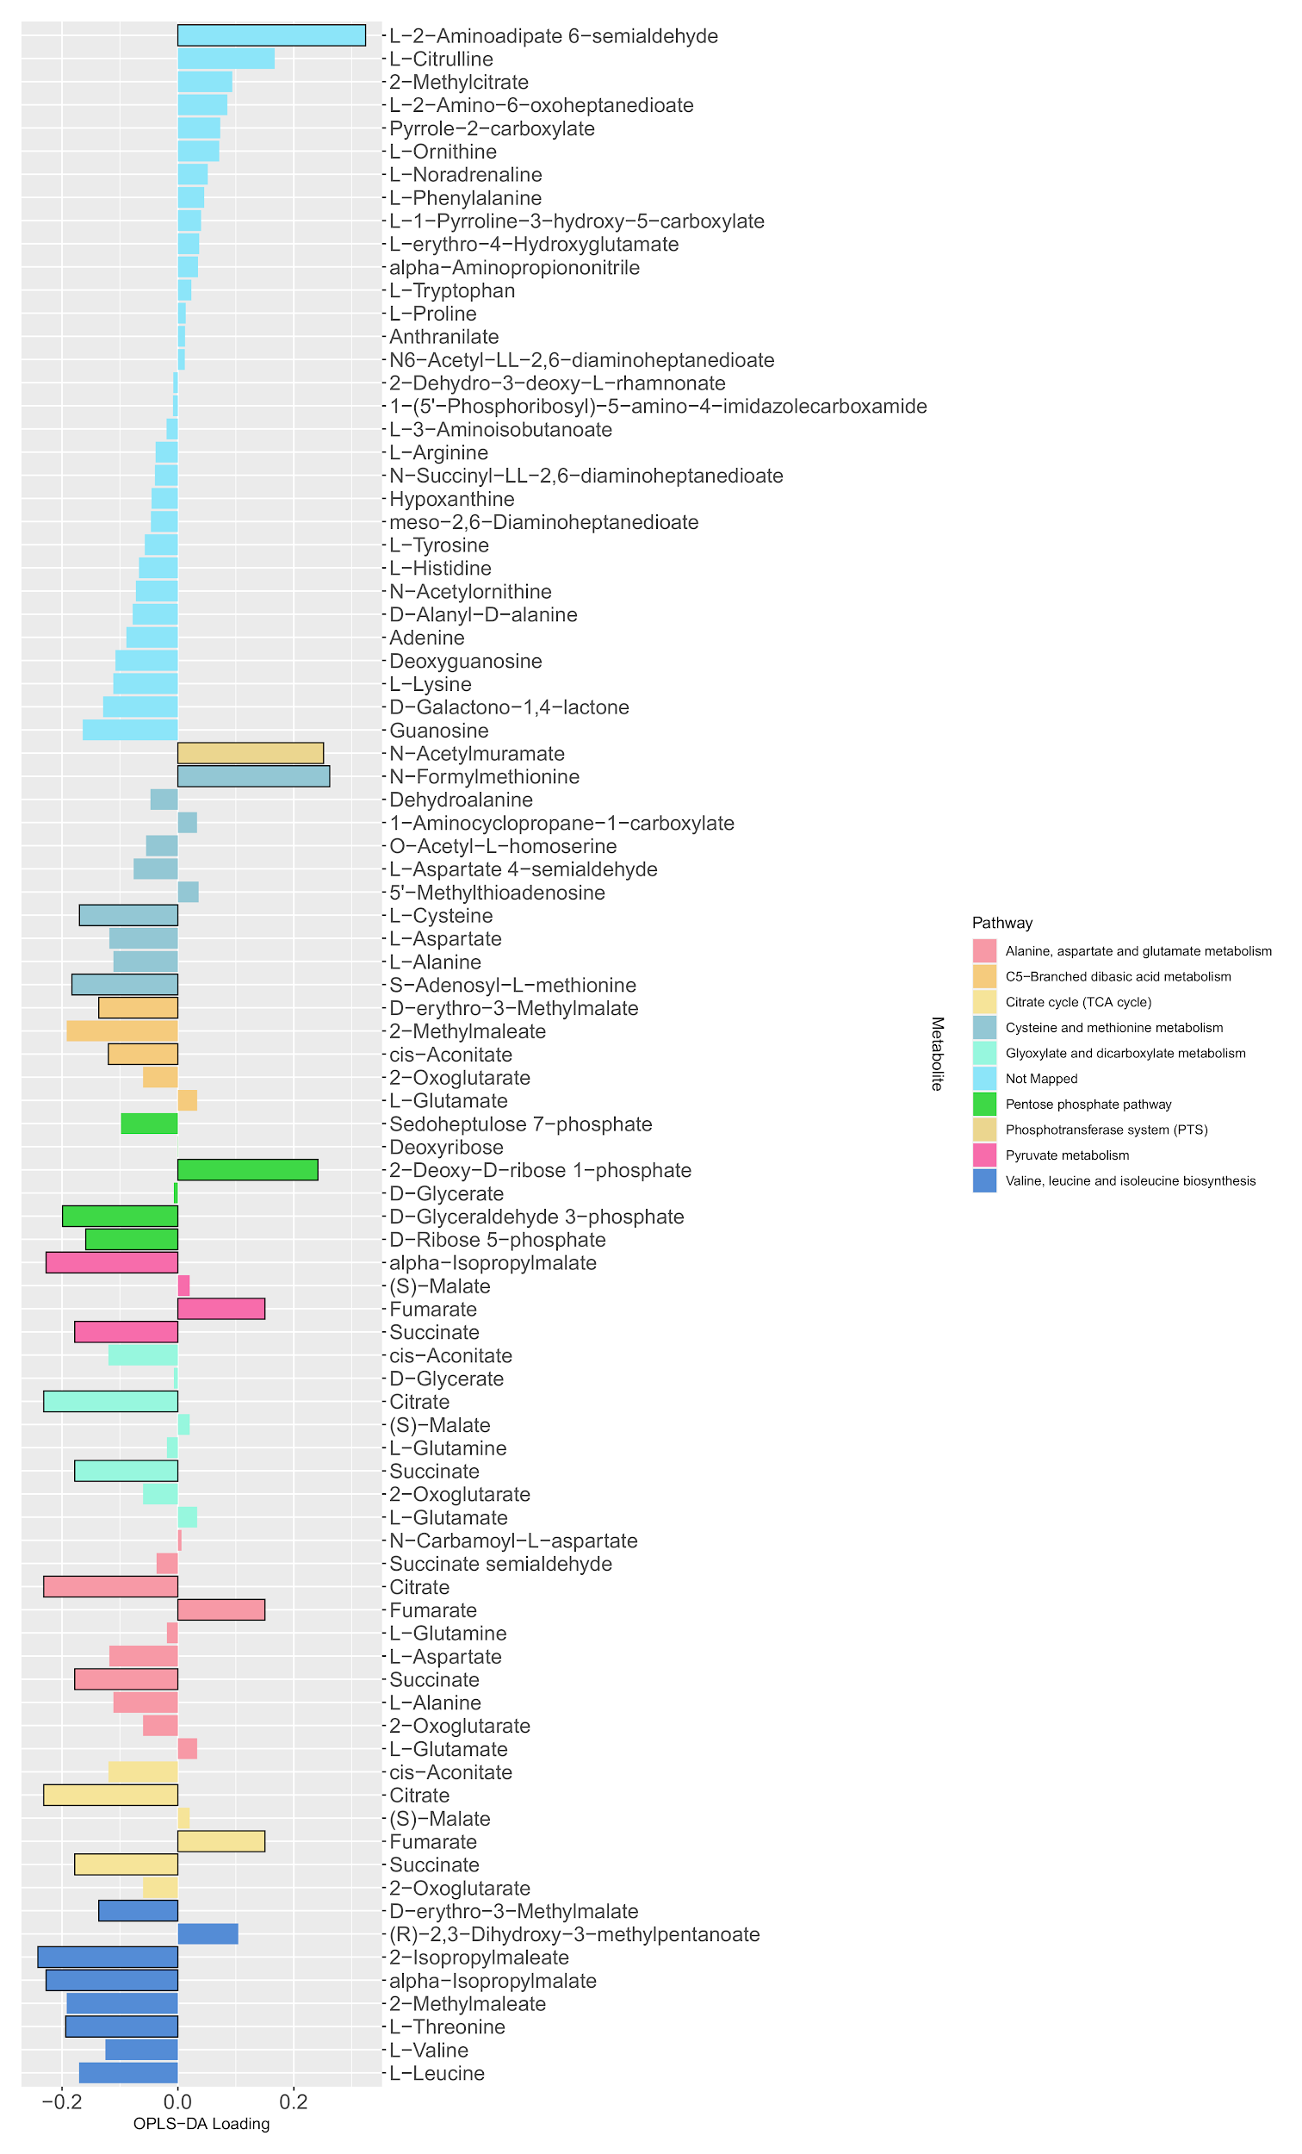

**Figure S4.** Loadings of the predictive component of the OPLS-DA model obtained to classify the strains according to if they produce or not rhamnolipids. The differential metabolites between producers and non-producers were determined by a Mann Whitney test (adjusted *p-*values with Bonferroni-Hochberg method) with a level of significance of 0.05 (bars with black outline) and used as input for a metabolic pathway enrichment with FELLA algorithm. The colors indicate the mapped pathway for each one of the metabolites.

**Rhamnolipid production requires redox homeostasis**

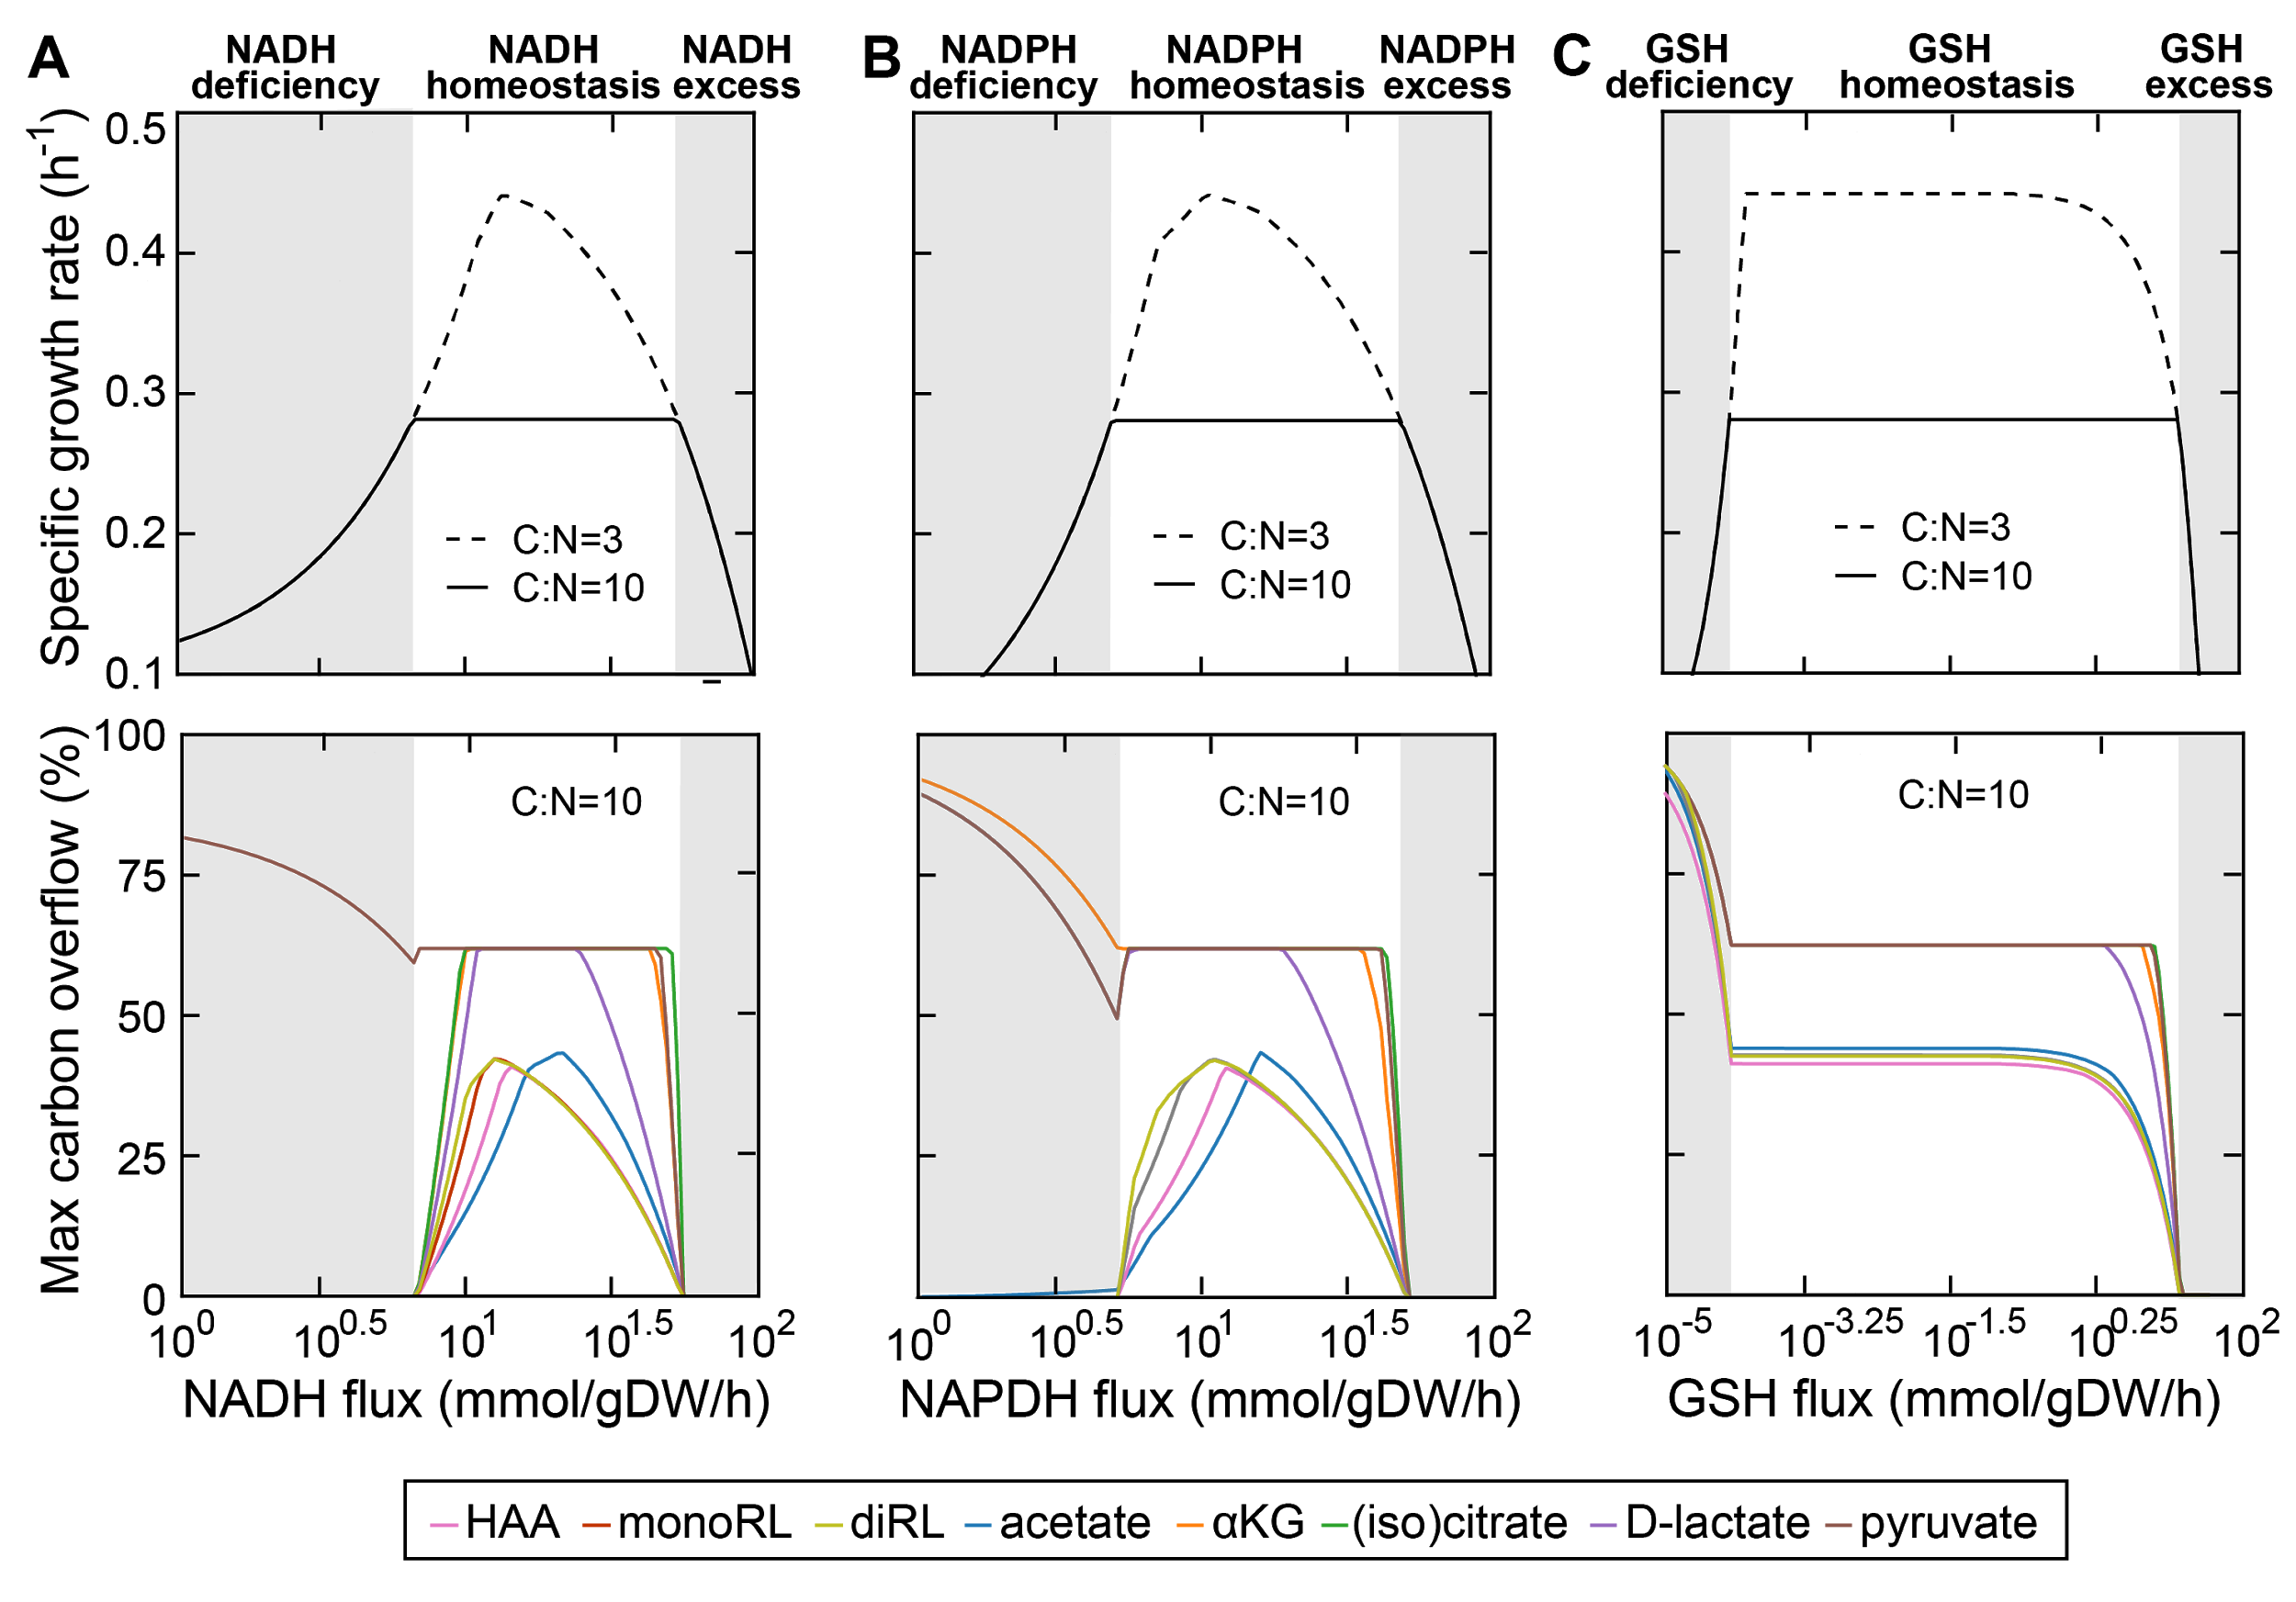

**Figure 5** Growth and rhamnolipid secretion are constrained by redox status. The redox stress levels are perturbed by altering fluxes of NADH (reduced nicotinamide adenine dinucleotide; **A**), NADPH (reduced nicotinamide adenine dinucleotide phosphate; **B**) and GSH (reduced glutathione; **C**). Upper panels are predicted maximum growth rates and lower panels are predicted maximum byproduct secretion fluxes. C:N indicates the carbon-to-nitrogen ratio between glycerol and ammonium in the culture medium. Abbreviations: HAA: 3-(3-hydroxyalkanoyloxy) alkanoate; monoRL: monorhamnolipid; diRL: dirhamnolipid; aKG: alpha-ketoglutarate. dash line:

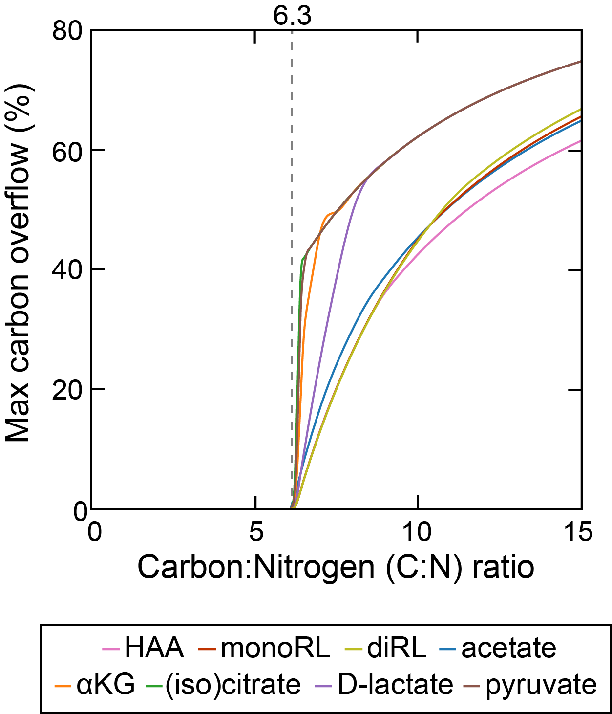

**Supplementary Figure S5** Theoretical estimation of threshold carbon (glycerol):nitrogen (ammonium) ratio above which carbon is in excess in the sense that carbon release through rhamnolipids and central carbon metabolites does not compromise biomass production. Abbreviations: HAA: 3-(3-hydroxyalkanoyloxy)alkanoate; monoRL: monorhamnolipid; diRL: dirhamnolipid; aKG: alpha-ketoglutarate.

To verify our hypothesis that rhamnolipids are not secreted under oxidative stress conditions, we used a genome-scale model of *Pseudomonas* metabolism to simulate the maximum growth rate and rhamnolipid secretion potential under different redox stress levels. The culture medium used for simulations is the same as the experimental setup with glycerol and ammonium as the sole carbon and nitrogen sources respectively. Since rhamnolipids are produced when carbon is in excess, we set the carbon-to-nitrogen (C:N) ratio to 10.0, which exceeds the minimum C:N threshold (6.3) that permits rhamnolipid secretion while allowing fastest growth rate (Supp. Fig. X). The redox stress levels were computationally varied by changing the flux levels of three redox molecules, NADH (reduced nicotinamide adenine dinucleotide), NADPH (reduced nicotinamide adenine dinucleotide phosphate) and GSH (reduced glutathione), which are responsible for the bulk of cellular electron transfer and and likely to be the main sources of ROS (ref). For all three redox molecules, we found that the maximum growth rate is maintained at an intermediate flux range (redox homeostasis) while any deviation from the range (gray shading) gradually reduces growth rate (upper panels of A-C, Fig. X). Except for extremely small GSH flux, what generally accompanies the compromised growth rate is the abrupt shutdown in the potential of secretion of rhamnolipid precursors (HAA), mono- and di-rhamnolipids as well as many (but not all) central carbon metabolites (lower panels of A-C, Fig. X). Importantly, none of these secretion fluxes are mandatory and provides growth benefit (i.e., each individual flux can be as low as zero without compromising maximum growth rate), suggesting that carbon release through different pathways are equivalent from a metabolic network perspective. Collectively, these simulation results confirm the link between growth, rhamnolipid secretion, and redox stress, where growth and rhamnolipid secretion are both metabolically constrained by cellular redox status.

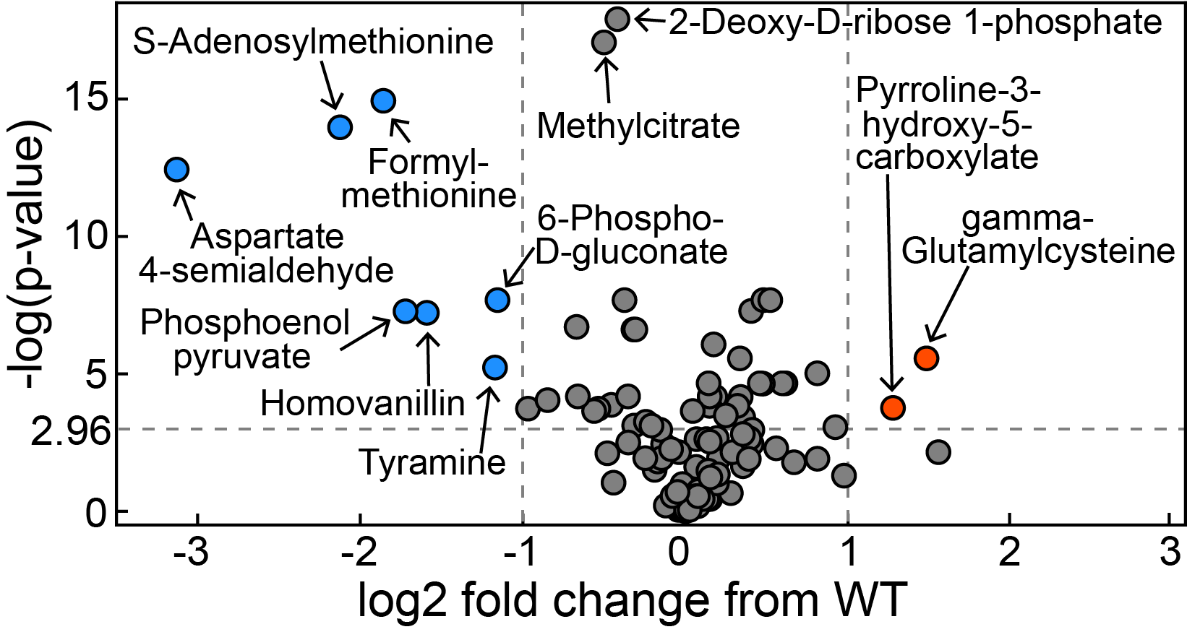

**Figure S6.** Volcano plot of metabolomics data between wild-type *P. aeruginosa* UCBPP-PA14 strain and its *rhlA* mutant (replotted from Boyle et al. 2017).

**Clinical isolates stop producing rhamnolipids when grown in succinate as sole carbon source**

We monitored the growth curve of the clinical isolates and the production of rhamnolipids in a synthetic medium with succinate as the sole carbon source in an analog way than the one exposed before for glycerol. Interestingly, all the strains that produce rhamnolipids when grown in glycerol become non-producers after growth in succinate. The growth curves showed that the isolates transited directly from phase 1 (exponential) to phase 3 (decay). Rhamnolipid production occurs in phase 2 (stationary). *P. aeruginosa* grows faster in succinate than in glycerol, and its lag phase is shorter [Dolan *et al.* 2020 DOI: [10.1128/mBio.02684-19](https://doi.org/10.1128/mbio.02684-19)]. Succinate enters the carbon metabolism directly through the TCA cycle. This faster growth might be producing an increased concentration of NAD(P)H that would cause the TCA cycle to stop. As succinate cannot be redirected to overflow metabolism neither rhamnolipid production cells transite from phase 1 to 3, as NAD(P)H concentration becomes toxic and cells stop sustaining the growth, producing a decay in the growth rate. Rhamnolipids therefore are not produced. The fact that in rhamnolipid non-producers grown in glycerol, despite the metabolomic data suggesting that TCA cycle is blocked during late phase 1 of growth, a sustained growth is observed and phase 2 is present, suggests that non-producer strains might be obtaining their energy from glycerol using a fermentative pathway. Rhamnolipid production might be a way of keeping the TCA cycle active during phases 1 and 2 of growth.

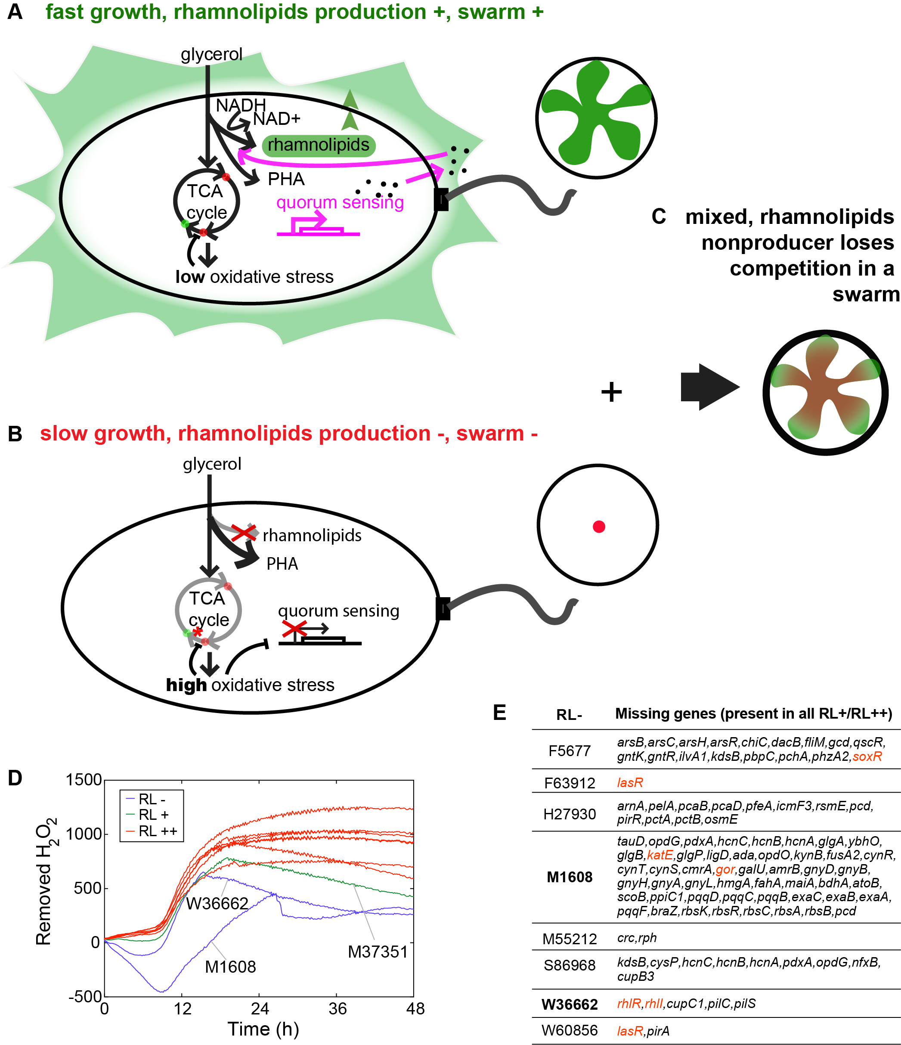

**Figure 6**. Metabolic model of rhamnolipids production in *P. aeruginosa*. A) During aerobic growth, cells rely on the TCA cycle to generate energy molecules such as NADH and invest in biomass. B) When cells reach a certain density and nitrogen becomes limited, rhamnolipids production is turned on by quorum sensing and this step consumes NADH. Enzymes that facilitate cell growth at this condition are synthesized and some proteins are recycled with fMet as a degradation signal. At the same time, TCA cycle is slowed down by redox stress. For the strains that could produce rhamnolipids, the membrane redox stress is partially released and therefore the flux between succinate and fumarate is less reduced (*), resulting in higher fumarate level than in rhamnolipids nonproducer. red dots: metabolites whose levels are lower in rhamnolipids producers; green dots: metabolites whose levels are higher in rhamnolipids producers.

**Discussion**

Secondary metabolism such as rhamnolipids production is usually associated with environmental stress such as nutrient limitation. Nitrogen limitation especially is ubiquitous in the microbial world. High C:N ratio is found in the intestine of 30 mammals including humans and it shapes microbiome composition (https://www.nature.com/articles/s41564-018-0267-7). Therefore understanding bacterial metabolism in nutrient imbalance and how it shapes cell-cell interaction is crucial to understand the emerging of social traits. *P. aeruginosa* uses metabolic prudence to prioritize the nutrient investment to biomass production when both nitrogen and carbon are abundant. When nitrogen becomes limited and carbon remains excessive, *P. aeruginosa* secretes rhamnolipids as public goods that enable the population to move cooperatively as a swarm and explore new territories. How cellular metabolic networks regulate individual cell growth and social cooperation, two traits that are usually considered tradeoffs through evolution? How to prevent cheating even in the individual level? How cellular metabolism impacts structured bacterial communities? Our phylogenetic analysis shows that the ancestor of *P. aeruginosa* strains is a rhamnolipids producer and this phenotype remains relatively stable across the phylogenetic tree. Gene sequence analysis confirms that *rhlA* is highly conserved in all of our clinical isolations even in rhamnolipids non producers, further supporting that this pathway, although not essential, is under stringent selection along evolution. In this study, our systematic analysis reveals that rhamnolipids production couples individual cell growth to social cooperative traits.

Previous studies showed that rhamnolipids production is strictly regulated by quorum sensing signal (N-butanoyl-L-homoserine lactone [C4-HSL] binding to RhlR). Here in our clinical isolates, we found that a few rhamnolipids non-producers indeed lose quorum sensing regulators and quorum sensing synthesis enzyme. However, the losing of quorum sensing genes could not explain all the non-producing phenotype: other non-producers lose genes involving central carbon catabolism or energy producing pathways *etc.,* indicating a link between rhamnolipids, carbon metabolism and energy processing. The expression of *rhlAB* operon is not constitutive but activated when cells switch from a fast growing stage into a slow growing stage in the presence of excessive carbon (doi.org/10.1371/journal.pcbi.1004279). The tight temporal regulation prevented the invasion of cheaters in a swarm even though they can free ride rhamnolipids to expand (doi.org/10.1111/j.1365-2958.2010.07436.x). Deleting *rhlA* or C4-HSL did not increase the growth rate of *P. aeruginosa* in liquid glycerol media (doi.org/10.1186/1471-2180-11-140), indicating that the carbon used for rhamnolipids production does not interfere with biomass production. Would this tight coupling of growth and rhamnolipids production impose any advantage? In a swarm, when cell reaches certain density and nitrogen becomes scarce but not completely deprived, the extra carbon is used to support cell growth in a lower rate as well as to produce rhamnolipids that can break the surface tension and enable the population to expand to places with more nutrients that enable cell proliferation. We hypothesize that *P. aeruginosa* rely on redox homeostasis to achieve this beautiful coordination of cellular growth and social translocation.On the other hand, if cells fail to lower the ratio between NAD(P)H and NAD(P),high concentrations of NAD(P)H can act as a source of ROS: they are toxic to the cell and inhibit cell growth (Murphy 2008 doi: [10.1042/BJ20081386](https://dx.doi.org/10.1042%2FBJ20081386), Esterházy *et al*. 2008 doi: 10.1021/bi702243b. Vinogradov and Grivennikova 2016<https://doi.org/10.1016/j.bbabio.2015.11.004>, Larosa and Remacle 2018 doi: [10.1042/BSR20171492](https://dx.doi.org/10.1042%2FBSR20171492)).

How could this mechanism be implemented? Why don’t we see cells keep growing at a high growth rate? The capacity of TCA cycle turns out to be limited by either cell membrane capacity for electron transport chain complexes needed for NADH oxidation (Szenk *et al.* 2017 doi: 10.1016/j.cels.2017.06.005., Andersen and Meyenburg 1980 DOI: [10.1128/JB.144.1.114-123.1980](https://www.researchgate.net/deref/http%3A%2F%2Fdx.doi.org%2F10.1128%2FJB.144.1.114-123.1980?_sg%5B0%5D=4a4VfWx217JL1ZWFRFKETzqKft_yGEr0HnJglpQUxqdqy-tCbo_7etRr3MNCbtgVdzj1kya18LwxnoXMiznzl8VdsA.rKKt_pzBl2pXsLGsmCantLZCsJWeKQQaZceq6ymNy5TXVYGQZ-qmR7SrufEVgbwJJlFpAqhhRkgP_Hjs-VKv7g)), or by proteome efficiency during respiration (Basan *et al.* 2015 doi:10.1038/nature15765.)

We use metabolic flux analysis to demonstrate that high NAD(P)H and GSH flux coupling with high C:N ratio can indeed lead to production of HAA, mono-rhamnolipid, acetate and lactate etc. Another association between rhamnolipids production and NADH flux is RhlG, an enzyme upstream of RhlA that catalyzes the synthesis of β-hydroxy acid moiety of rhamnolipids. RhlG functions as an NADPH-dependent β-ketoacyl-acyl carrier protein (ACP) reductase (DOI: 10.1128/JB.180.17.4442-4451.1998), indicating the the restoration of redox homeostasis could happen before *rhlAB* is activated

Why is it important to secrete the extra metabolites outside the cells? There can be reasons such as detoxification, recycling of nutrients for diauxie, or help with selection for social traits. Another well known polymer produced by *P. aeruginosa* is polyhydroxyalkanoate (PHA, mainly polyhydroxybutyrate [PHB]), which shares common precursors with rhamnolipids (ref) and can also be induced by nitrogen starvation. Unlike rhamnolipids that are secreted outside of bacterial cells and shared by the entire population as ‘public goods’, PHA molecules are stored inside cells as granules and kept as ‘private’ resources that can increase stress tolerance of *P. aeruginosa* cells (DOI 10.1099/mic.0.27357-0). This strategy, although would increase cell resistance to environmental stress, does not contribute to population expansion. The interplay between intracellular and intracellular polymer production would greatly facilitate cell adaptation through evolution.

Overall, our analysis, for the first time, reveals that metabolic constraints impose both individual advantage (growth rate) and social advantage (swarming) for *P. aeruginosa* and rhamnolipids production greatly facilitate this regulation, which may lead to swarming diversity.

**Materials and Methods**

**Rhamnolipid production determination**

The production of rhamnolipids was assessed by drop-collapse assay. We placed 50 μL of the culture’s supernatant on a polystyrene surface (the lid of a 96 well plate). The presence of rhamnolipids decreases the surface tension of the liquid, making the drop collapse (Jain and Collins n.d.; Chen et al. 2007).

**Growth curve assay**

The clinical isolates were inoculated in 3 mL of LB and incubated 37ºC overnight with shaking. 500 μL of cell culture was pelleted and washed 3 times with PBS. 0.0025 OD600 units were inoculated into glycerol minimal medium in BD Falcon (BD Biosciences, San Jose, CA) 96 well flat-bottom plates, with 150 μL of suspension per well. The plate was incubated during 48 hours at 37ºC in a Tecan Infinite M1000 or Tecan Infinite M1000 Pro plate reader (Männedorf, Switzerland), with an orbital shaking of 4 mm of amplitude. OD600 was measured in 10 minutes intervals.

**Swarming assay**

Swarming assays were performed as described previously (Xavier et al. 2011; van Ditmarsch et al. 2013). The clinical isolates were inoculated in 3 mL of LB and incubated at 37ºC overnight, with shaking. 500 μL of the culture was pelleted and washed twice with PBS. 2 μL of this suspension was spotted on the surface of casamino acids soft agar plates, without penetrating the agar with the pipette tip. The plates were incubated at 37ºC ~24 hours. Two replicates were done per strain. In each batch of swarming assays PA14 was used as control.

**Swarming score**

Swarming score ($S_{i}$) for each clinical isolate $i$ is defined as a linear combination of the maximum length () and circularity () of its swarming colony

$S_{i} = 0.5994494 · (L_{i} - \underline{L}) - 0.8004127 · (C_{i} - \underline{C})$

where $\underline{L}$ and $\underline{C}$ are the mean values of $L_{i}$ and $C_{i}$ across all clinical isolates respectively.

**Imaging**

Images of the swarming plates were obtained with a Chemidoc gel doc imager (Bio Rad).

**Image analysis and determination of swarming score**

The extraction of the morphological features from the images of the swarming plates were analyzed using Matlab bwmorph function. The features extracted from the images were perimeter of the colony, maximum length (the longitude of the rectangle that fits the colony), area percentage of the plate occupied by the colony, circularity, measured as 4*π/P2, skeleton and eccentricity (the eccentricity of the fitted ellipse).

The analysis of the morphological features was performed in R. The average of the replicates for each feature was obtained. The values of each feature in each experiment were normalized to the value of PA14 control in that experiment. A PCA biplot was generated and maximum length and circularity were found to be the features that most spreaded swarmers and non swarmers. These two features were the one used for obtaining the swarming score (Equation 1). The coefficients in the equation correspond to the rotation of the two features that maximizes the variance of swarming score.

**Intracellular Metabolites extraction**

**Metabolomic data preprocessing**

Missing values, if any of the replicates had a non-missing value for the particular compound, were imputed to the average of the non missing values. After that imputation all compounds with missing values were removed (Fig. S4). 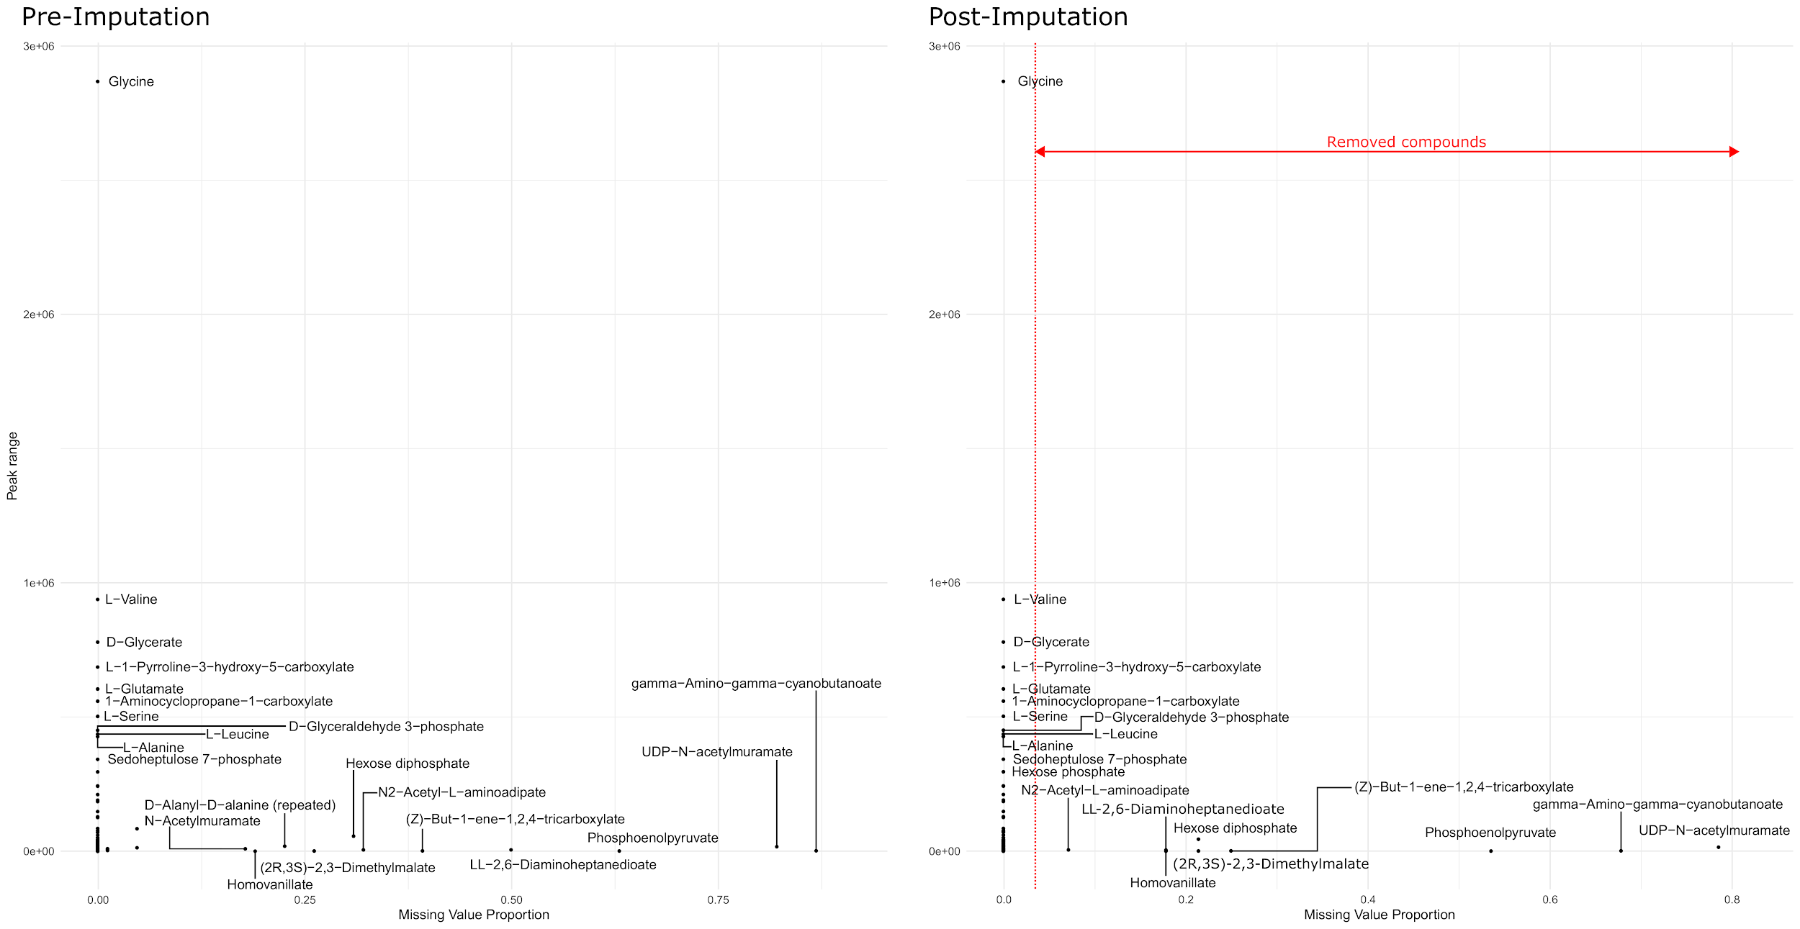

**Figure S4:** Quality of LC-MS measures of each one of the compounds, pre and post imputation. The peak range refers to the maximum peak area minus the minimum peak area. The imputation consisted in, for the compounds that had missing values only in some of the replicates of a same clinical isolate for a given compound, impute the missing values by the average of the replicates with an actual value. After the imputation the compounds with a missing value proportion above 0 were dropped out.

The peak areas were normalized using Cross-Contribution Compensating Multiple Standard Normalization (CCMN) (Redestig et al. 2009 doi: 10.1021/ac901143w) with NormalizeMets R package (De Livera *et al*. 2018 https://doi.org/10.1007/s11306-018-1347-7). This method relies on the use of multiple internal standards, but as the LC-MS was done without using them we used instead a set of metabolites assumed to be constant across all the strains. They were selected with a Kuskal-Wallis test, adjusting the *p-*value with Benjamini-Hochberg method. The ones with a *p-*value above 0.05 were considered constant, therefore after the normalization step they were removed (in black in Fig. 2A).

**Hierarchical Clustering Analysis of metabolomic data**

The Hierarchical Clustering Analysis of the normalized metabolomic data was performed using gplots R package (Warnes *et al.* 2015), with Euclidean distance and Ward’s aggregation method (Ward 1963). The clustering was done with all the metabolites from preprocessed metabolomic table, despite the experimentalists were not confident about the identity of 16 compounds (indicated in red in Figure 2A): we assumed that if the peaks appeared in all the strains they could not be artifacts of the LC-MS. These compounds are not shown in the heatmap of Figure 2B, and were not used in downstream analyses. Fumarate and Guanosine were initially categorized as ambiguous by the experimentalists, but we rescued them as our clinical isolates only had enzymatic genes related to them among all the possible compounds with the same molecular weight, according to KEGG database.

**Metabolic pathway enrichment**

The differential metabolites between rhamnolipid producers and non producers was determined by a Mann-Whitney test, with *p*-values adjusted with Benjamini-Hochberg method, with a significance level of 0.05. These compounds were fed to FELLA algorithm [Picart-Armada 2018 doi: 10.1186/s12859-018-2487-5]. The graph over which FELLA was performed consisted of all entries in the KEGG database for *Pseudomonas aeruginosa* strain UCBPP-PA14. We filtered the results table to keep only the metabolic pathways.

**OPLS-DA model**

OPLS-DA model of metabolomics data was built using ropls R package (Thévenot et al. 2015), fixing the number of orthogonal components to 3. R2 and Q2, key parameters for assessing the validity of the model, were assessed with 7-fold cross validation. The significance of the model was determined by permutation test (n = 2000). The *p*-value corresponds to the proportion of Q2perm above Q2. With a *p-*value below 0.05 we considered the model significant. The loadings of the predictive component of the model were extracted to determine how each metabolite contributes to the separation according to the phenotype.

J. Overhage, M. Bains, M. D. Brazas, and R. E. W. Hancock, “Swarming of Pseudomonas aeruginosa is a complex adaptation leading to increased production of virulence factors and antibiotic resistance,” *J. Bacteriol.*, vol. 190, no. 8, pp. 2671–2679, 2008.

Kearns DB. A field guide to bacterial swarming motility. Nat Rev Microbiol. 2010 Sep;8(9):634-44. doi: 10.1038/nrmicro2405. Epub 2010 Aug 9. PMID: 20694026; PMCID: PMC3135019.

[Trends Microbiol.](https://www.ncbi.nlm.nih.gov/pubmed/18775660) 2008 Oct;16(10):496-506. doi: 10.1016/j.tim.2008.07.004. Epub 2008 Sep 3.

**Living on a surface: swarming and biofilm formation.**

[Verstraeten N](https://www.ncbi.nlm.nih.gov/pubmed/?term=Verstraeten%20N%5BAuthor%5D&cauthor=true&cauthor_uid=18775660)1, [Braeken K](https://www.ncbi.nlm.nih.gov/pubmed/?term=Braeken%20K%5BAuthor%5D&cauthor=true&cauthor_uid=18775660), [Debkumari B](https://www.ncbi.nlm.nih.gov/pubmed/?term=Debkumari%20B%5BAuthor%5D&cauthor=true&cauthor_uid=18775660), [Fauvart M](https://www.ncbi.nlm.nih.gov/pubmed/?term=Fauvart%20M%5BAuthor%5D&cauthor=true&cauthor_uid=18775660), [Fransaer J](https://www.ncbi.nlm.nih.gov/pubmed/?term=Fransaer%20J%5BAuthor%5D&cauthor=true&cauthor_uid=18775660), [Vermant J](https://www.ncbi.nlm.nih.gov/pubmed/?term=Vermant%20J%5BAuthor%5D&cauthor=true&cauthor_uid=18775660), [Michiels J](https://www.ncbi.nlm.nih.gov/pubmed/?term=Michiels%20J%5BAuthor%5D&cauthor=true&cauthor_uid=18775660).

[Trends Microbiol.](https://www.ncbi.nlm.nih.gov/pubmed/24051005) 2013 Oct;21(10):508-9. doi: 10.1016/j.tim.2013.08.003. Epub 2013 Sep 16.

**You get what you select for: better swarming through more flagella.**

[Kearns DB](https://www.ncbi.nlm.nih.gov/pubmed/?term=Kearns%20DB%5BAuthor%5D&cauthor=true&cauthor_uid=24051005)1.

[Adv Wound Care (New Rochelle).](https://www.ncbi.nlm.nih.gov/pubmed/24527289) 2012 Jun;1(3):109-114.

**Molecular Mechanisms of Biofilm Infection: Biofilm Virulence Factors.**

[Phillips PL](https://www.ncbi.nlm.nih.gov/pubmed/?term=Phillips%20PL%5BAuthor%5D&cauthor=true&cauthor_uid=24527289)1, [Schultz GS](https://www.ncbi.nlm.nih.gov/pubmed/?term=Schultz%20GS%5BAuthor%5D&cauthor=true&cauthor_uid=24527289)1.

[Antimicrob Agents Chemother.](https://www.ncbi.nlm.nih.gov/pubmed/8913456) 1996 Nov;40(11):2517-22.

**Theoretical aspects of antibiotic diffusion into microbial biofilms.**

[Stewart PS](https://www.ncbi.nlm.nih.gov/pubmed/?term=Stewart%20PS%5BAuthor%5D&cauthor=true&cauthor_uid=8913456)1.

[Int J Antimicrob Agents.](https://www.ncbi.nlm.nih.gov/pubmed/20149602) 2010 Apr;35(4):322-32. doi: 10.1016/j.ijantimicag.2009.12.011. Epub 2010 Feb 10.

**Antibiotic resistance of bacterial biofilms.**

[Høiby N](https://www.ncbi.nlm.nih.gov/pubmed/?term=H%C3%B8iby%20N%5BAuthor%5D&cauthor=true&cauthor_uid=20149602)1, [Bjarnsholt T](https://www.ncbi.nlm.nih.gov/pubmed/?term=Bjarnsholt%20T%5BAuthor%5D&cauthor=true&cauthor_uid=20149602), [Givskov M](https://www.ncbi.nlm.nih.gov/pubmed/?term=Givskov%20M%5BAuthor%5D&cauthor=true&cauthor_uid=20149602), [Molin S](https://www.ncbi.nlm.nih.gov/pubmed/?term=Molin%20S%5BAuthor%5D&cauthor=true&cauthor_uid=20149602), [Ciofu O](https://www.ncbi.nlm.nih.gov/pubmed/?term=Ciofu%20O%5BAuthor%5D&cauthor=true&cauthor_uid=20149602).

Driffield K, Miller K, Bostock M, O’Neill AJ, Chopra I. Increased muta- bility of Pseudomonas aeruginosa in biofilms. J Antimicrob Chemother 2008;61:1053–6.

Molin S, Tolker-Nielsen T. Gene transfer occurs with enhanced efficiency in biofilms and induces enhanced stabilisation of the biofilm structure. Curr Opin Biotechnol 2003;14:255–61.

[Biophys J.](https://www.ncbi.nlm.nih.gov/pubmed/28402888) 2017 Apr 11;112(7):1462-1471. doi: 10.1016/j.bpj.2017.02.019.

**Influence of Physical Effects on the Swarming Motility of Pseudomonas aeruginosa.**

[Yang A](https://www.ncbi.nlm.nih.gov/pubmed/?term=Yang%20A%5BAuthor%5D&cauthor=true&cauthor_uid=28402888)1, [Tang WS](https://www.ncbi.nlm.nih.gov/pubmed/?term=Tang%20WS%5BAuthor%5D&cauthor=true&cauthor_uid=28402888)2, [Si T](https://www.ncbi.nlm.nih.gov/pubmed/?term=Si%20T%5BAuthor%5D&cauthor=true&cauthor_uid=28402888)3, [Tang JX](https://www.ncbi.nlm.nih.gov/pubmed/?term=Tang%20JX%5BAuthor%5D&cauthor=true&cauthor_uid=28402888)4.

Shrout, J. D., D. L. Chopp, C. L. Just, M. Hentzer, M. Givskov, and M. R. Parsek. 2006. The impact of quorum sensing and swarming motility on Pseudomonas aeruginosa biofilm formation is nutritionally conditional. Mol. Microbiol. 62:1264–1277

[Proc Natl Acad Sci U S A.](https://www.ncbi.nlm.nih.gov/pubmed/20133590) 2010 Feb 23;107(8):3776-81. doi: 10.1073/pnas.0910934107. Epub 2010 Feb 2.

**Cell density and mobility protect swarming bacteria against antibiotics.**

[Butler MT](https://www.ncbi.nlm.nih.gov/pubmed/?term=Butler%20MT%5BAuthor%5D&cauthor=true&cauthor_uid=20133590)1, [Wang Q](https://www.ncbi.nlm.nih.gov/pubmed/?term=Wang%20Q%5BAuthor%5D&cauthor=true&cauthor_uid=20133590), [Harshey RM](https://www.ncbi.nlm.nih.gov/pubmed/?term=Harshey%20RM%5BAuthor%5D&cauthor=true&cauthor_uid=20133590).

J. Yan *et al.*, “Bow-tie signaling in c-di-GMP: Machine learning in a simple biochemical network,” *PLoS Comput. Biol.*, vol. 13, no. 8, p. e1005677, 2017.

[Nucleic Acids Symp Ser (Oxf).](https://www.ncbi.nlm.nih.gov/pubmed/19749255) 2009;(53):51-2. doi: 10.1093/nass/nrp026.

# **Multiple activities of c-di-GMP in Pseudomonas aeruginosa.**

[Lory S](https://www.ncbi.nlm.nih.gov/pubmed/?term=Lory%20S%5BAuthor%5D&cauthor=true&cauthor_uid=19749255)1, [Merighi M](https://www.ncbi.nlm.nih.gov/pubmed/?term=Merighi%20M%5BAuthor%5D&cauthor=true&cauthor_uid=19749255), [Hyodo M](https://www.ncbi.nlm.nih.gov/pubmed/?term=Hyodo%20M%5BAuthor%5D&cauthor=true&cauthor_uid=19749255).

Hengge R (2009) Principles of c-di-GMP signalling in bacteria. Nature reviews Microbiology 7: 263– 273. https://doi.org/10.1038/nrmicro2109 PMID: 19287449

[J Med Microbiol.](https://www.ncbi.nlm.nih.gov/pubmed/20093376) 2010 May;59(Pt 5):511-20. doi: 10.1099/jmm.0.017715-0. Epub 2010 Jan 21.

# **Swarming motility, secretion of type 3 effectors and biofilm formation phenotypes exhibited within a large cohort of Pseudomonas aeruginosa clinical isolates.**

[Murray TS](https://www.ncbi.nlm.nih.gov/pubmed/?term=Murray%20TS%5BAuthor%5D&cauthor=true&cauthor_uid=20093376)1, [Ledizet M](https://www.ncbi.nlm.nih.gov/pubmed/?term=Ledizet%20M%5BAuthor%5D&cauthor=true&cauthor_uid=20093376), [Kazmierczak BI](https://www.ncbi.nlm.nih.gov/pubmed/?term=Kazmierczak%20BI%5BAuthor%5D&cauthor=true&cauthor_uid=20093376).

van Ditmarsch D, Boyle KE, Sakhtah H, Oyler JE, Nadell CD, et al. (2013) Convergent Evolution of Hyperswarming Leads to Impaired Biofilm Formation in Pathogenic Bacteria. Cell Reports 4: 697–708. https://doi.org/10.1016/j.celrep.2013.07.026 PMID: 23954787

Gillespie JH (2009) Natural selection with varying selection coefficients–a haploid model. Genetical Research 21: 115–120.

[J Bacteriol.](https://www.ncbi.nlm.nih.gov/pubmed/16237018/) 2005 Nov;187(21):7351-61.

# **Rhamnolipids modulate swarming motility patterns of Pseudomonas aeruginosa.**

[Caiazza NC](https://www.ncbi.nlm.nih.gov/pubmed/?term=Caiazza%20NC%5BAuthor%5D&cauthor=true&cauthor_uid=16237018)1, [Shanks RM](https://www.ncbi.nlm.nih.gov/pubmed/?term=Shanks%20RM%5BAuthor%5D&cauthor=true&cauthor_uid=16237018), [O'Toole GA](https://www.ncbi.nlm.nih.gov/pubmed/?term=O%27Toole%20GA%5BAuthor%5D&cauthor=true&cauthor_uid=16237018).

Inverse regulation of biofilm formation and swarming motility by Pseudomonas aeruginosa PA14.

*Caiazza NC, Merritt JH, Brothers KM, O'Toole GA*

*J Bacteriol. 2007 May; 189(9):3603-12.*

Gieger, C., L. Geistlinger, E. Altmaier, M. Hrabé de Angelis, F. Kronenberg, T. Meitinger, H.-W. Mewes, H.-E. Wichmann, et al. 2008. Genetics meets metabolomics: A genome-wide association study of metabolite profiles in human serum. PLoS Genet. 4:e1000282.

Jewett, M.C., G. Hofmann, and J. Nielsen. 2006. Fungal metabolite analysis in genomics and phenomics. Curr. Opin. Biotechnol. 17:191- 197.

Jain DK, Collins-Thompson DL, Lee H, Trevors JT. A drop-collapsing test for screening surfactant producing microorganisms. J. Microbiol. Meth. 1991; 13:271–279. 67.

Chen BG, Turner L, Berg HC. The wetting agent required for swarming in Salmonella enterica serovar typhimurium is not a surfactant. J. Bacteriol. 2007; 189:8750–8753. [PubMed: 17905988]

[Electrophoresis.](https://www.ncbi.nlm.nih.gov/pubmed/26376450) 2015 Dec;36(24):3050-60. doi: 10.1002/elps.201500352. Epub 2015 Oct 20.

# **Missing value imputation strategies for metabolomics data.**

[Armitage EG](https://www.ncbi.nlm.nih.gov/pubmed/?term=Armitage%20EG%5BAuthor%5D&cauthor=true&cauthor_uid=26376450)1, [Godzien J](https://www.ncbi.nlm.nih.gov/pubmed/?term=Godzien%20J%5BAuthor%5D&cauthor=true&cauthor_uid=26376450)1, [Alonso-Herranz V](https://www.ncbi.nlm.nih.gov/pubmed/?term=Alonso-Herranz%20V%5BAuthor%5D&cauthor=true&cauthor_uid=26376450)1, [López-Gonzálvez Á](https://www.ncbi.nlm.nih.gov/pubmed/?term=L%C3%B3pez-Gonz%C3%A1lvez%20%C3%81%5BAuthor%5D&cauthor=true&cauthor_uid=26376450)1, [Barbas C](https://www.ncbi.nlm.nih.gov/pubmed/?term=Barbas%20C%5BAuthor%5D&cauthor=true&cauthor_uid=26376450)1.

Allogenic Hematopoietic Stem Cell transplantation (allo-HSCT henceforth) is an effective treatment against a big range of hematologic disorders [1]. It consists in two main phases: preconditioning and transplant. The preconditioning step involves antibiotic administration and, depending on the regime, ablation of the myeloid cells. It has been demonstrated that preconditioning can produce a decrease in the biodiversitiy of the gut microbiota, which often causes domination of the total population by a single antibiotic-resistant microorganism [2]–[4]. That can pave the way to disseminated infections from the gut to other tissues [5], [6]. As generalized infections are a leading cause in allo-HSCT patient morbidity and mortality [7], [8], research in reducing its prevalence is highly important.

Gram negative bacteremias, despite being less frequent than Gram positive ones, are associated with a higher mortality, with *Pseudomonas aeruginosa* being the most frequent pathogen among Gram negative allo-HSCT-induced sepsis [9]–[11]. *P. aeruginosa* has a wide range of virulence traits, many of them related to its motility phenotype. Some of the most important are the ability to form biofilms, swimming motility and intestine epithelium adhesiveness. Biofilm-forming *P. aeruginosa* strains cause chronical infections in Cystic Fibrosis patient’s lungs [13], [14]. Swimming motility and intestine epithelium adhesiveness have been related to epithelium-disruptive strains both *in-vivo* and *in-vitro* [15], [16], as well as the ability to penetrate the intestinal barrier by debilitating the tight junctions between the epithelial cells [17], while swarming motility has been linked to the production of virulence-related factors and antibiotic resistance [18].

*P. aeruginosa*, like in other bacteria, relies in a bow-tie c-di-GMP-based network to decide whether to form a biofilm or to swarm. This network is able to integrate different stimuli from the environment that translate in a intracellular concentration of c-di-GMP. If that concentration is above a certain threshold the cell stays in a sessile phenotype, while if it falls below the cell switches to swarming. FleN is a key protein in this regulation. Laboratory evolution in PA14 strain selecting for swarmers produce multiflagelled mutants in *fleN* gene that are perpetually locked in a swarming behaviour [van Ditmarsch et al. 2013]. After selection for biofilm the phenotype could be recovered. The obtained mutants had mutations in *dipA* and *wspF* genes, both related with c-di-GMP [Yan et al. 2017]. This link between genome, c-di-GMP levels and swarming-biofilm tradeoff was reported in laboratory conditions and with a laboratory strains, but has been proved to be difficult to establish across different strains [Yan et al. 2017, van Ditmarsch et al. 2013, Murray et al. 2010]. The strong selective pressure in a laboratory environment was selecting for specialists that had acquired few mutations that allowed them to change their behaviour. But during longer evolutionary histories the strains could be acquiring many mutations that make more difficult to establish the link between genome and phenotype.

Metabolomics is a promising approach for looking for this relationship, as the link between metabolome and phenotype is shorter than the one between genotype and phenotype [19, 20]. In this study we focus on a cohort of 28 *Pseudomonas aeruginosa* clinical isolates, obtained from acutely infected allo-HSCT patients from Memorial Sloan-Kettering Cancer Center. These strains are phylogenetically diverse, and show different swarming phenotypes that are not restricted to any clade of the phylogeny. The levels of c-di-GMP are neither correlated with the swarming behaviour of the strains. But the metabolite levels of these strains could reveal common patterns that could be product of a metabolic wiring shared across strains that share phenotypic traits.

The subject of this study is a cohort of 28 *P. aeruginosa* clinical isolates obtained from different body parts of acutely infected allo-HSCT patients from Memorial Sloan-Kettering Cancer Center that were also used in past of our studies. Their metabolites were extracted after culture in minimal media when they were in exponential phase of growth and analysed by Liquid Chromatography-Mass Spectrometry, with 3 replicates per strain. 96 compounds were identified, but after a curation that number was reduced to 70. The peak areas were log transformed and different normalization methods were tested, finally choosing Cross-contribution Compensating Normalization Method. As internal standards we chose a set of compounds that did not change across strains, determined by a Kruskal Wallis test.

The swarming was characterized by spotting 2 µL of a OD600 ~1 in soft agar Petri dishes. After 16 hours of 37˚C incubation the swarm area and the circularity was measured. The two measures were normalized to range from 0 to 1, a PCA was did and the values for principal component one were obtained (principal component 1 contained 88.9% of the variance of the data). This way we obtained a single value that combined circularity and area. Growth curves in minimal medium were also obtained for each one of the strains by measuring the OD600 at 10 minutes intervals during 48 hours. The production of rhamnolipids was also determined by the observation of the shape of the supernatant drop after growth in minimal medium.

The CCMN normalized metabolomic data was clustered using euclidean distance as distance measure, and Ward D aggregation method. All replicates clustered together, with the exception of one of H47921, that was removed because its values were very different to the ones from the other 2 replicates, and a replicate of W36662 and T63266, respectively. Those last two replicates did not move far away in the dendrogram, so we decided to keep them. The cluster was done using all compounds 96 compounds (the ambiguous and the unambiguous ones), being represented in the figure only the unambiguous ones. Two major clusters were obtained, one of them having higher abundance of many of the detected compounds. The strains that swarm the most clustered all together. In the principal component analysis of the metabolomics data was also possible to see that the strains that have a similar swarming phenotype aggregate (Figure X). That showed that metabolite abundance and swarming phenotype are closely related, which lead us to apply a supervised approach to the analysis of the data. We chose Orthogonal Projections for Latent Structures, as it is widely used in metabolomics with a high success. As a response variable for the model we used principal component 1 scores stated before (obtained from normalized swarm area and circularity). We then selected the compounds with most extreme loading values in component p1, meaning that they are the ones that most contribute to separate the strains according to how much they swarm in the model.

The compounds that more contribute to the separation of the strains according to swarming were then used as input for metabolic pathway enrichment. The approach chosen was FELLA. This R package applies diffusion algorithms over an undirected and unweighted graph that consists in all the entries that exist in KEGG for a given organism, in this case *Pseudomonas aeruginosa*, strain PAO1. The output consists in a subgraph with all the entries that have a high probability of receiving the simulated flux that diffusion algorithm pumps into the network through the input compounds’ nodes. The entries in that subgraph are the nodes with highest connectivity within the global graph. The nodes in that subgraph labelled as “pathway” would be the metabolic pathways that would be potentially perturbed. The output of FELLA also include enzymes linked to the compounds of interest. This enzymes could be the ones that are different between strains in terms of presence/absence or sequence and might be causing the observed differences in metabolite abundance.

We quantified the swarming of each strain by spotting 2 µL of suspension in soft agar Petri dishes. These were incubated during 16 h at 37˚C and the swarm was measured in terms of area percentage, circularity, perimeter and larger diameter of the colony. A PCA was done using these measures, and as circularity and area percentage were the ones that better separated the strains, we did another PCA using only these 2 measures and kept the scores in the first principal component to be used as the quantification of swarming. The strains that swarm the most have a negative value, while the ones that do not swarm have a positive value. Then we applied a OPLS-DA analysis to the CCMN-normalized metabolomic data, using that swarming measure as the response variable (Figure X). The top left plot shows the R2 and Q2 for each one of the orthogonal components of the data. The component p1 is the one that is separating the data according to the swarming: contains the variance that is correlated to swarming. This, in the bottom right plot, corresponds to the X axis. So the loadings of each one of the compounds for this component will represent how much their abundance correlates with swarming. The top right plot is the diagnosis plot. We didn’t separate the data in training and testing, because the number of samples we have is not very high. Instead of that the algorithm has the option of using all samples, compute R2 and Q2 (the grey and black lines, respectively), and later permutate the values of the Y response variable (swarming), for fitting a new model in each round of permutation, computing the correspondent R2 and Q2 values (grey and black dots, respectively). R2 and Q2 are a measure of how fit is the model to the data. They indicate how much of the variance of the data is explained by the model, in the case of R2 with known data (training), and in the case of Q2 with unknown data (training) (we didn’t did a partition of the data, but it seems to be some rounds of cross-validation internally in the function). So if the model works well we should see a relatively high R2 and a slightly lower, but still close Q2. When working with datasets with much more variables than samples the model could show a high Q2 value because of overfitting. Label permutation is useful to assess if that is happening. If the model is not good, the models obtained after permutation could have a higher R2 and Q2 than the obtained with the actual data, meaning that the variables could not be very related with the response variable. In this case the model is working well: we have high R2 and Q2 and all the permutation values are below the actual ones.

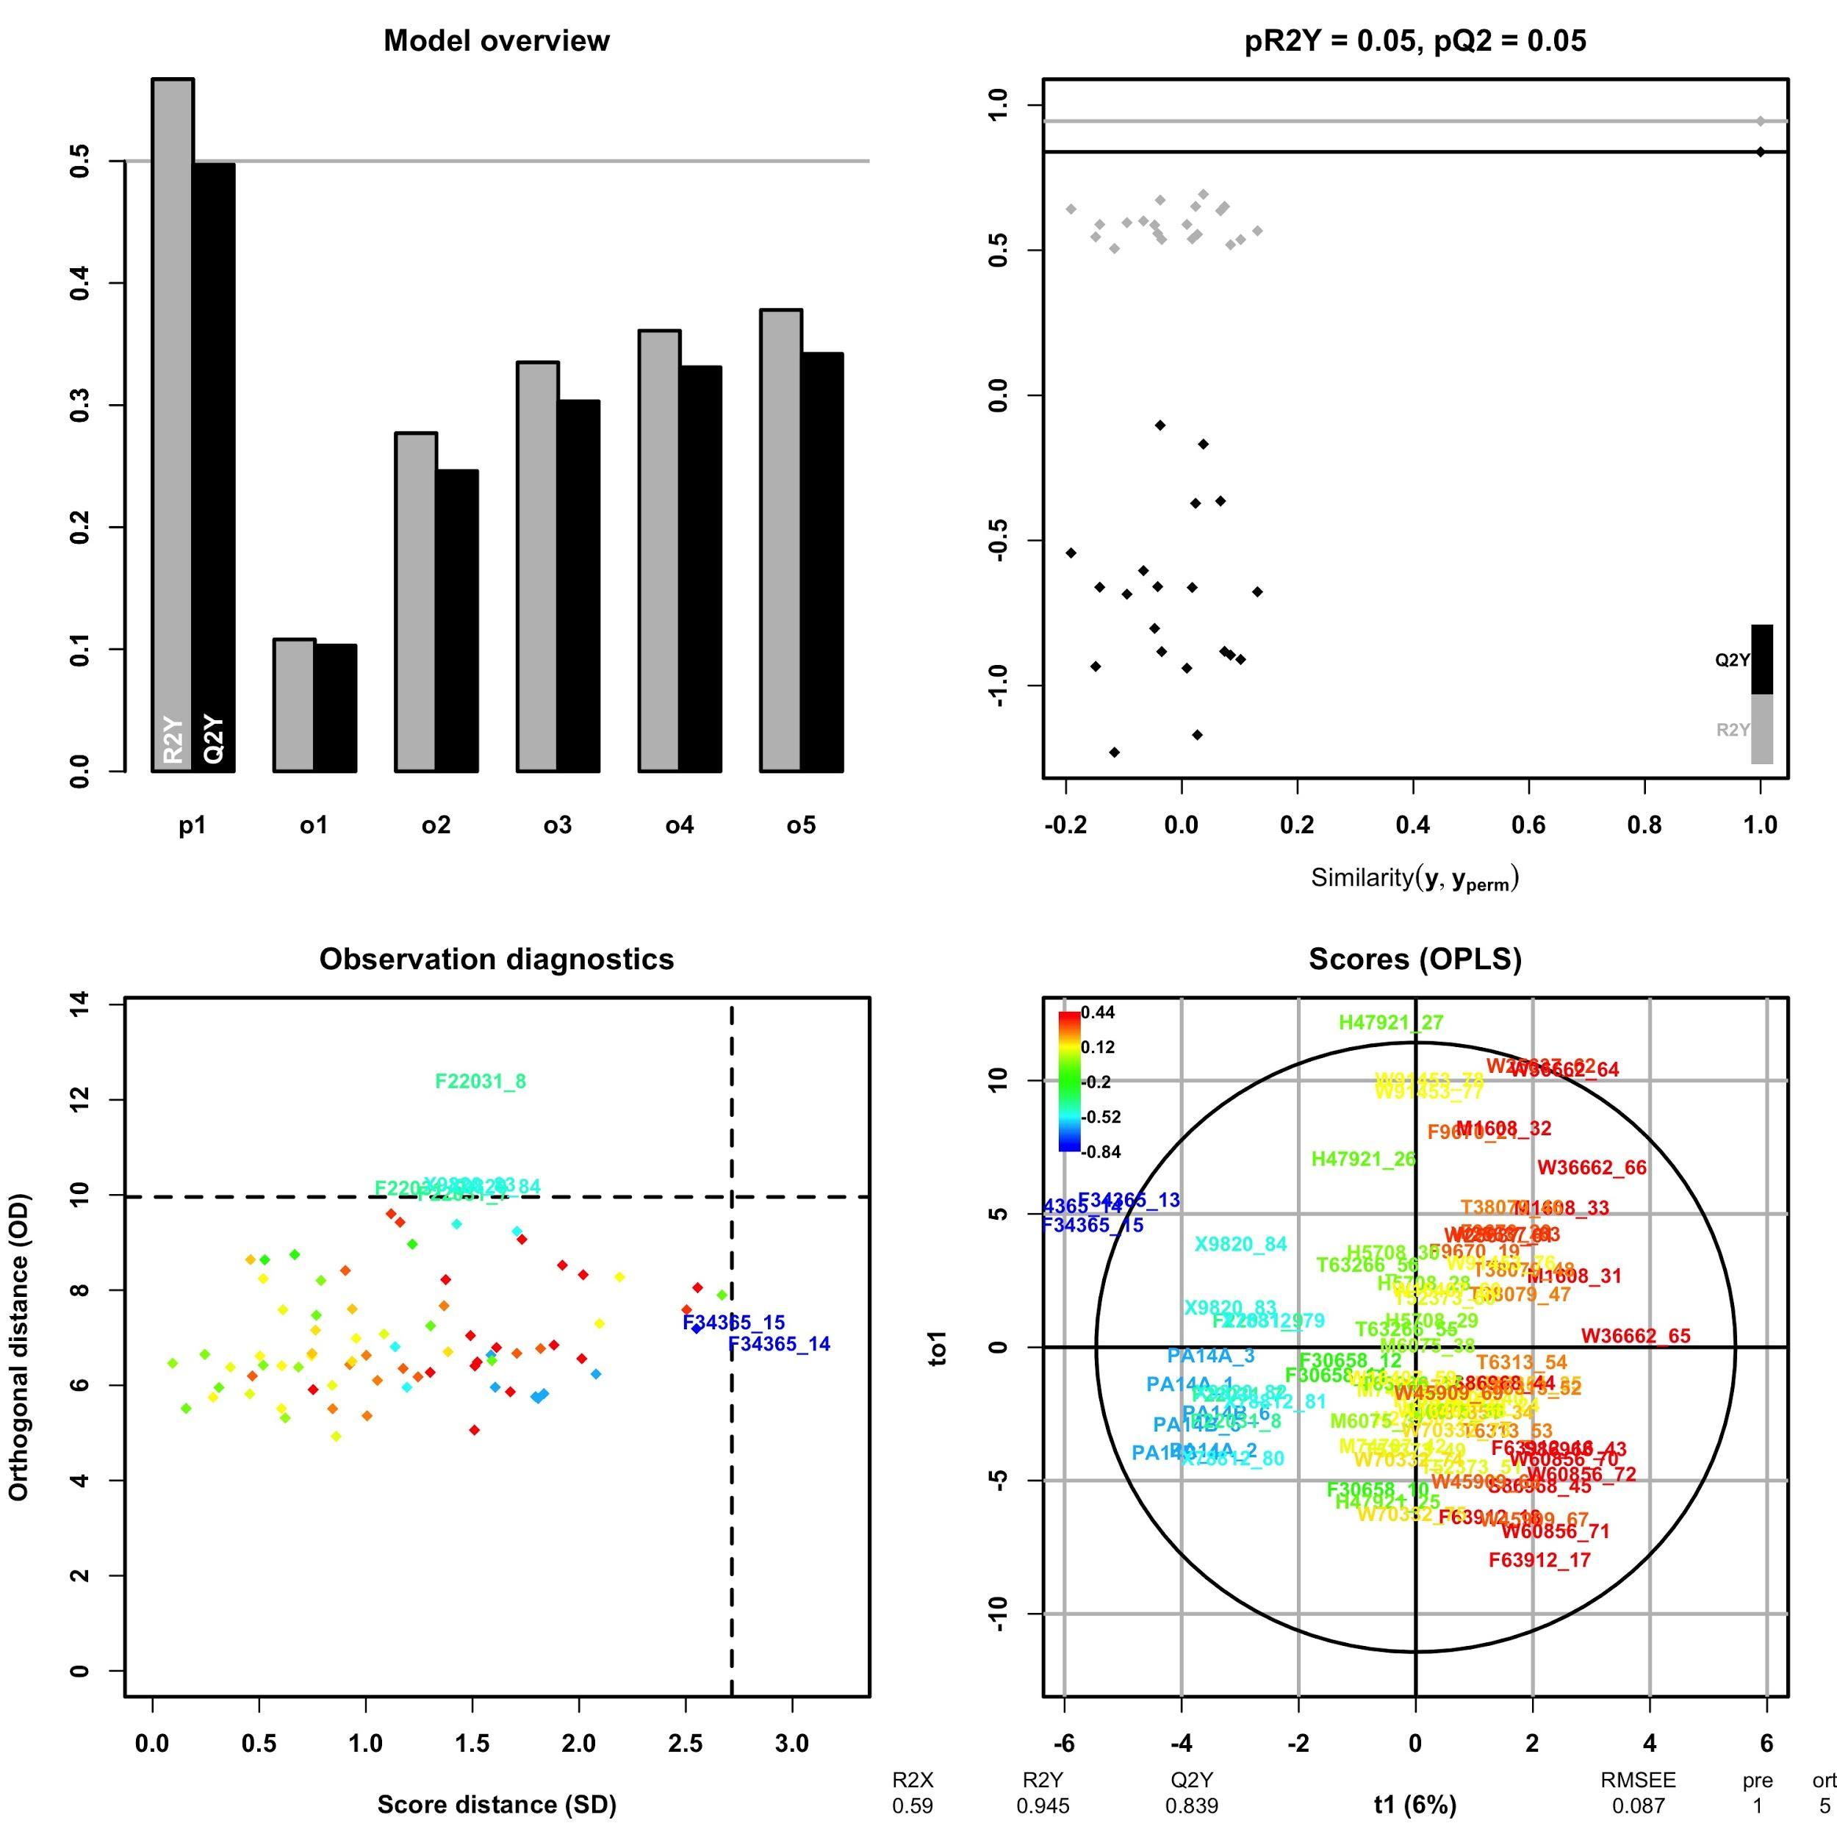

So we obtained the loadings for component p1 and removed the compounds with ambiguous ID (figure X). The compounds appear ordered according to how they contribute to the response variable. As the swarmers have negative values, the compounds with negative loading value are the ones that are found in higher abundance in the strains that swarm.

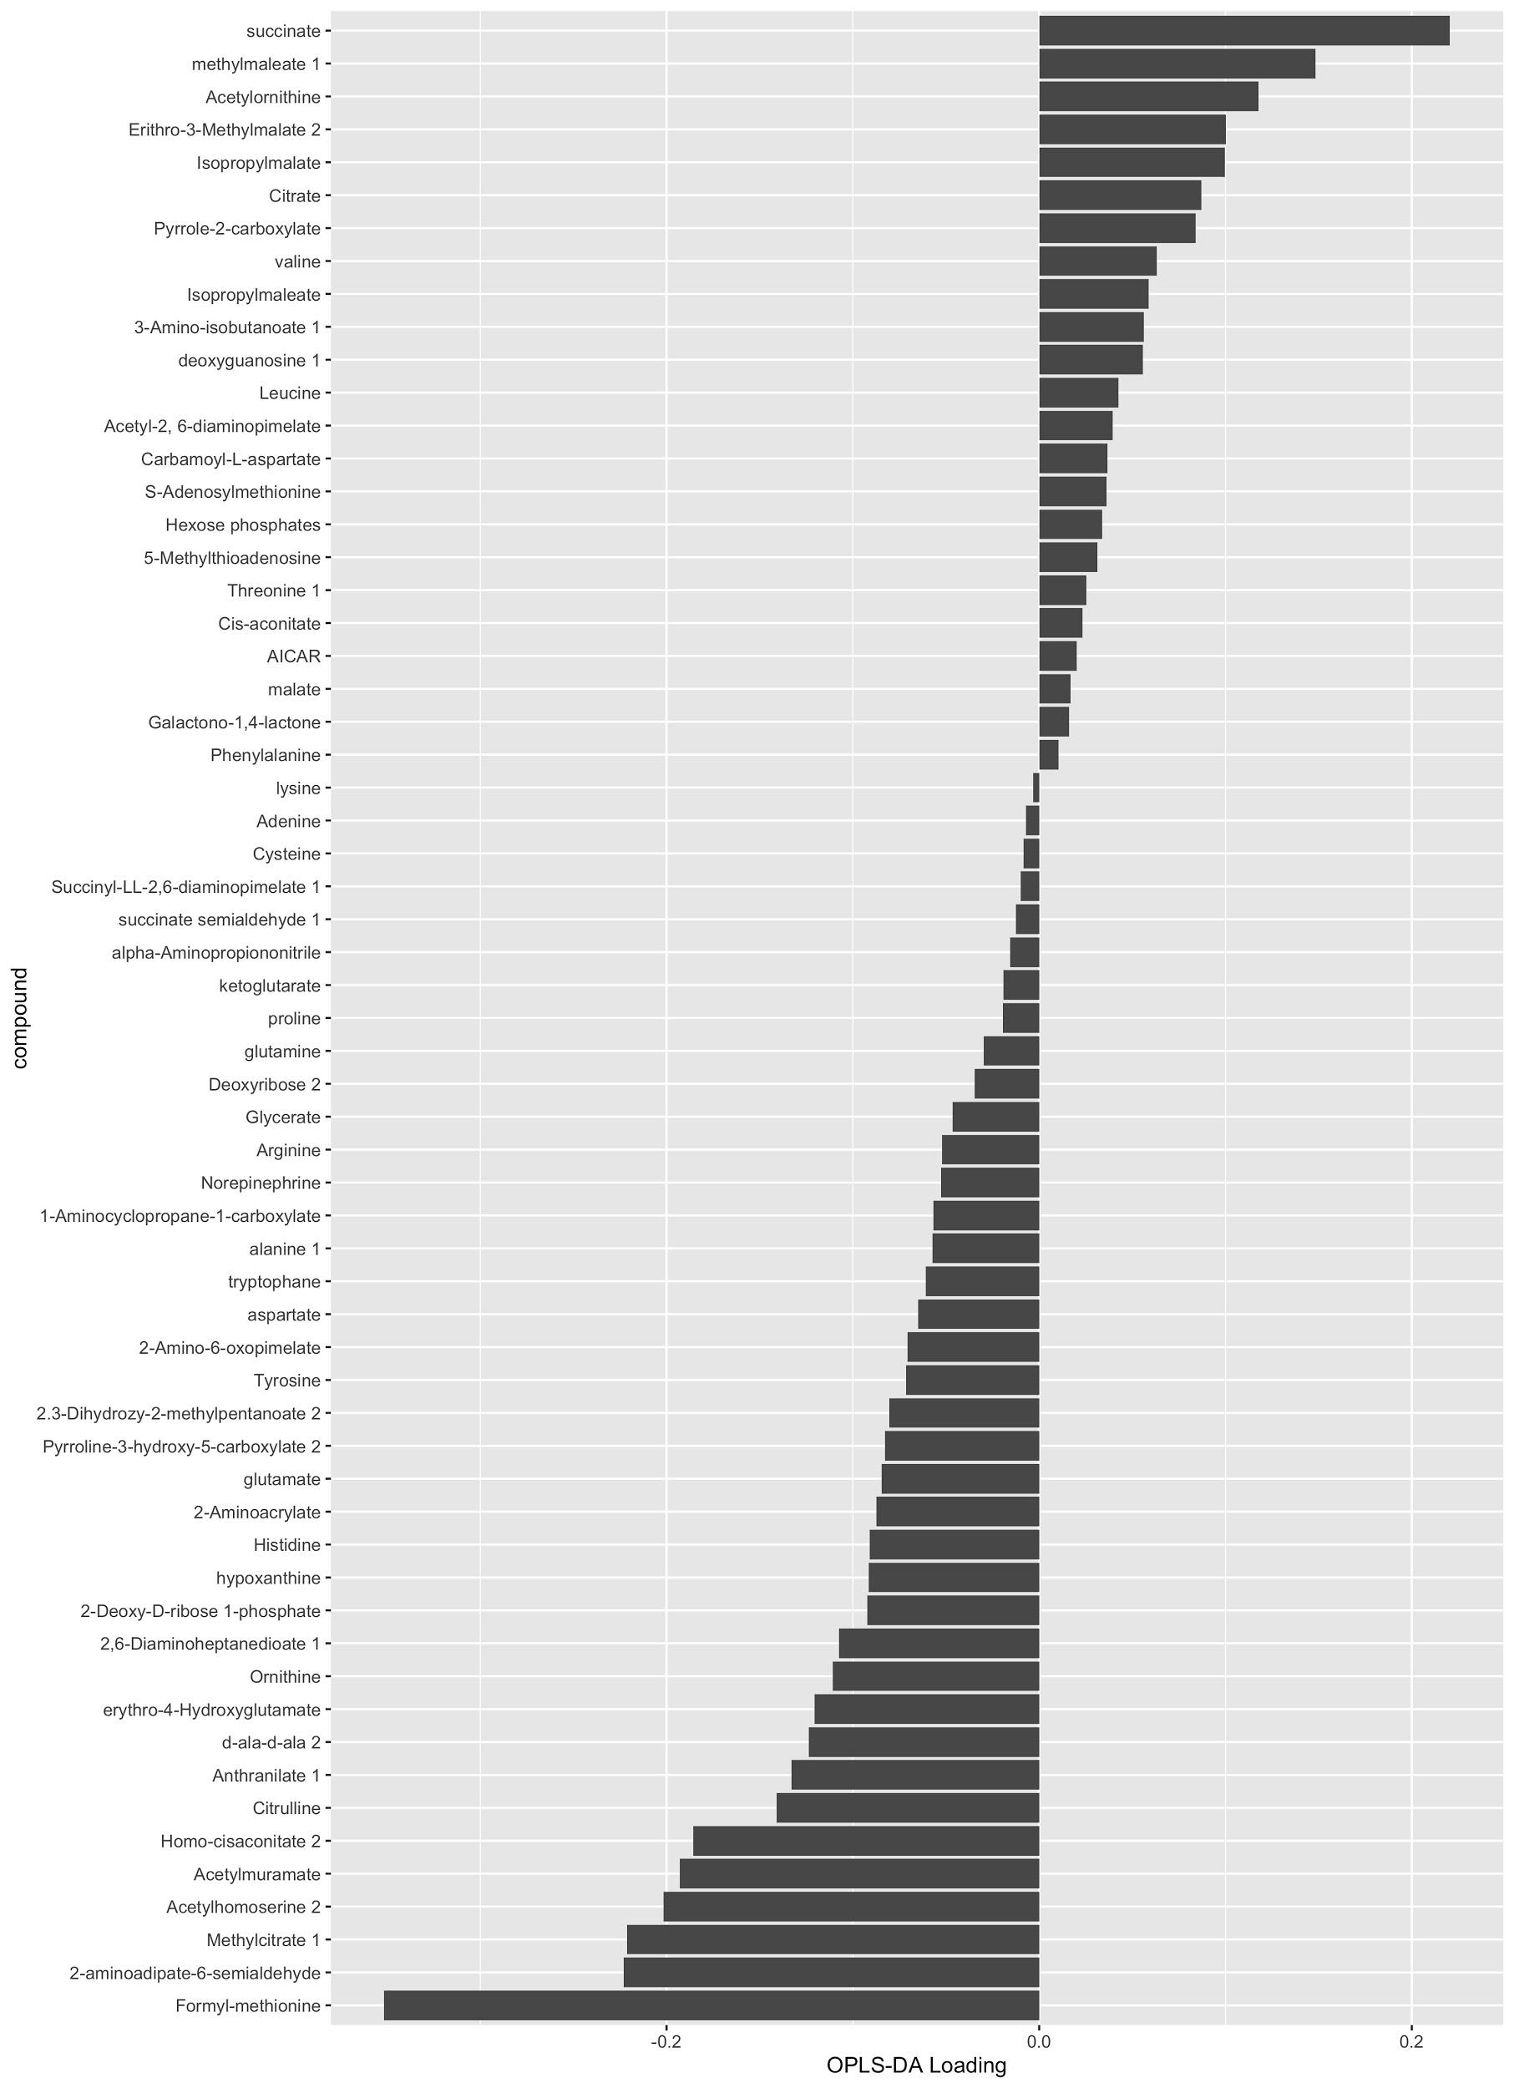

Then we applied the same approach using as input data the presence or absence of enzymatic genes, coded as zeros and ones. Previously we grouped the genes that have the same or very similar pattern of presence/absence across strains, using Jaccard similarity (0.95 or above). Here we also obtain a good separation, but the Q2 is significatively lower than the R2, and after label permutation many values are above the actual ones, suggesting that is difficult to do a good model with this data: is difficult to predict how much a strain is going to swarm using the presence/absence of the enzymatic accessory genome. Despite this we wanted to know if some information could be extracted from these results. By one side we selected the 5 groups of genes with most extreme loading values, above and below, and unpacked them. The presence and absence of these genes is shown in Figure X. The strains appear sorted according to how much they swarm, being in the left the ones that swarm the most and in the right the ones that swarm the least.

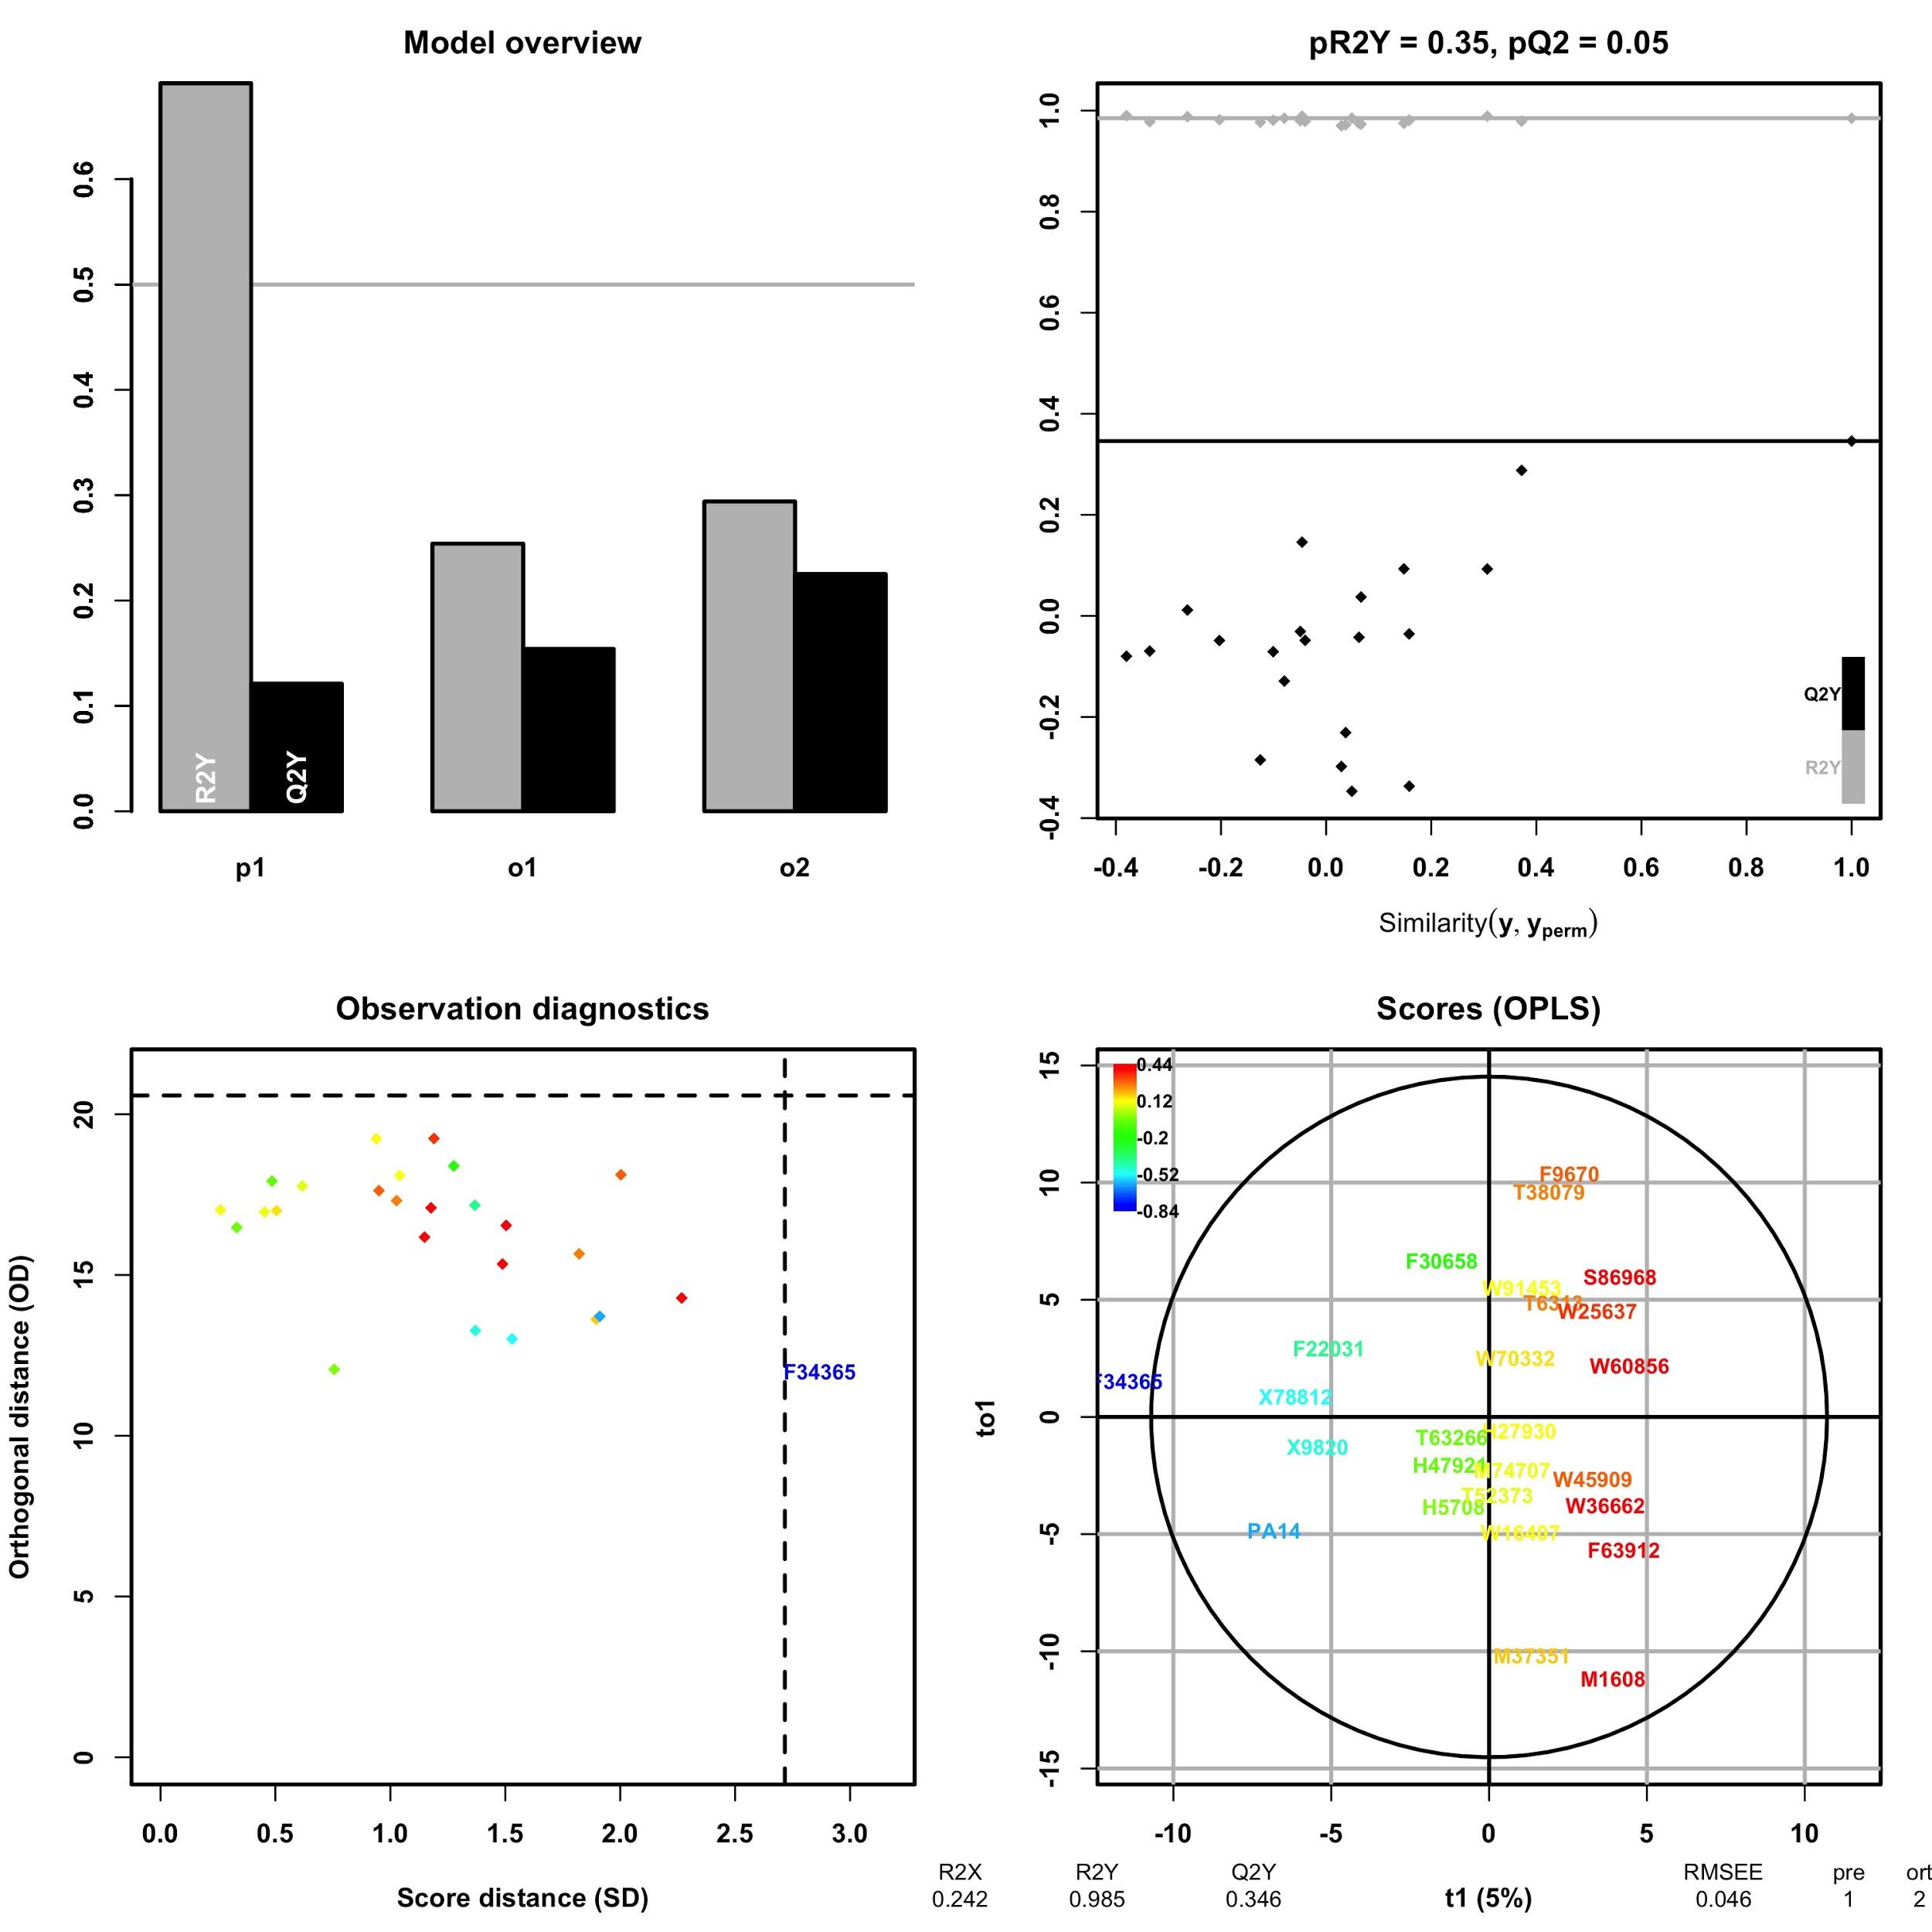

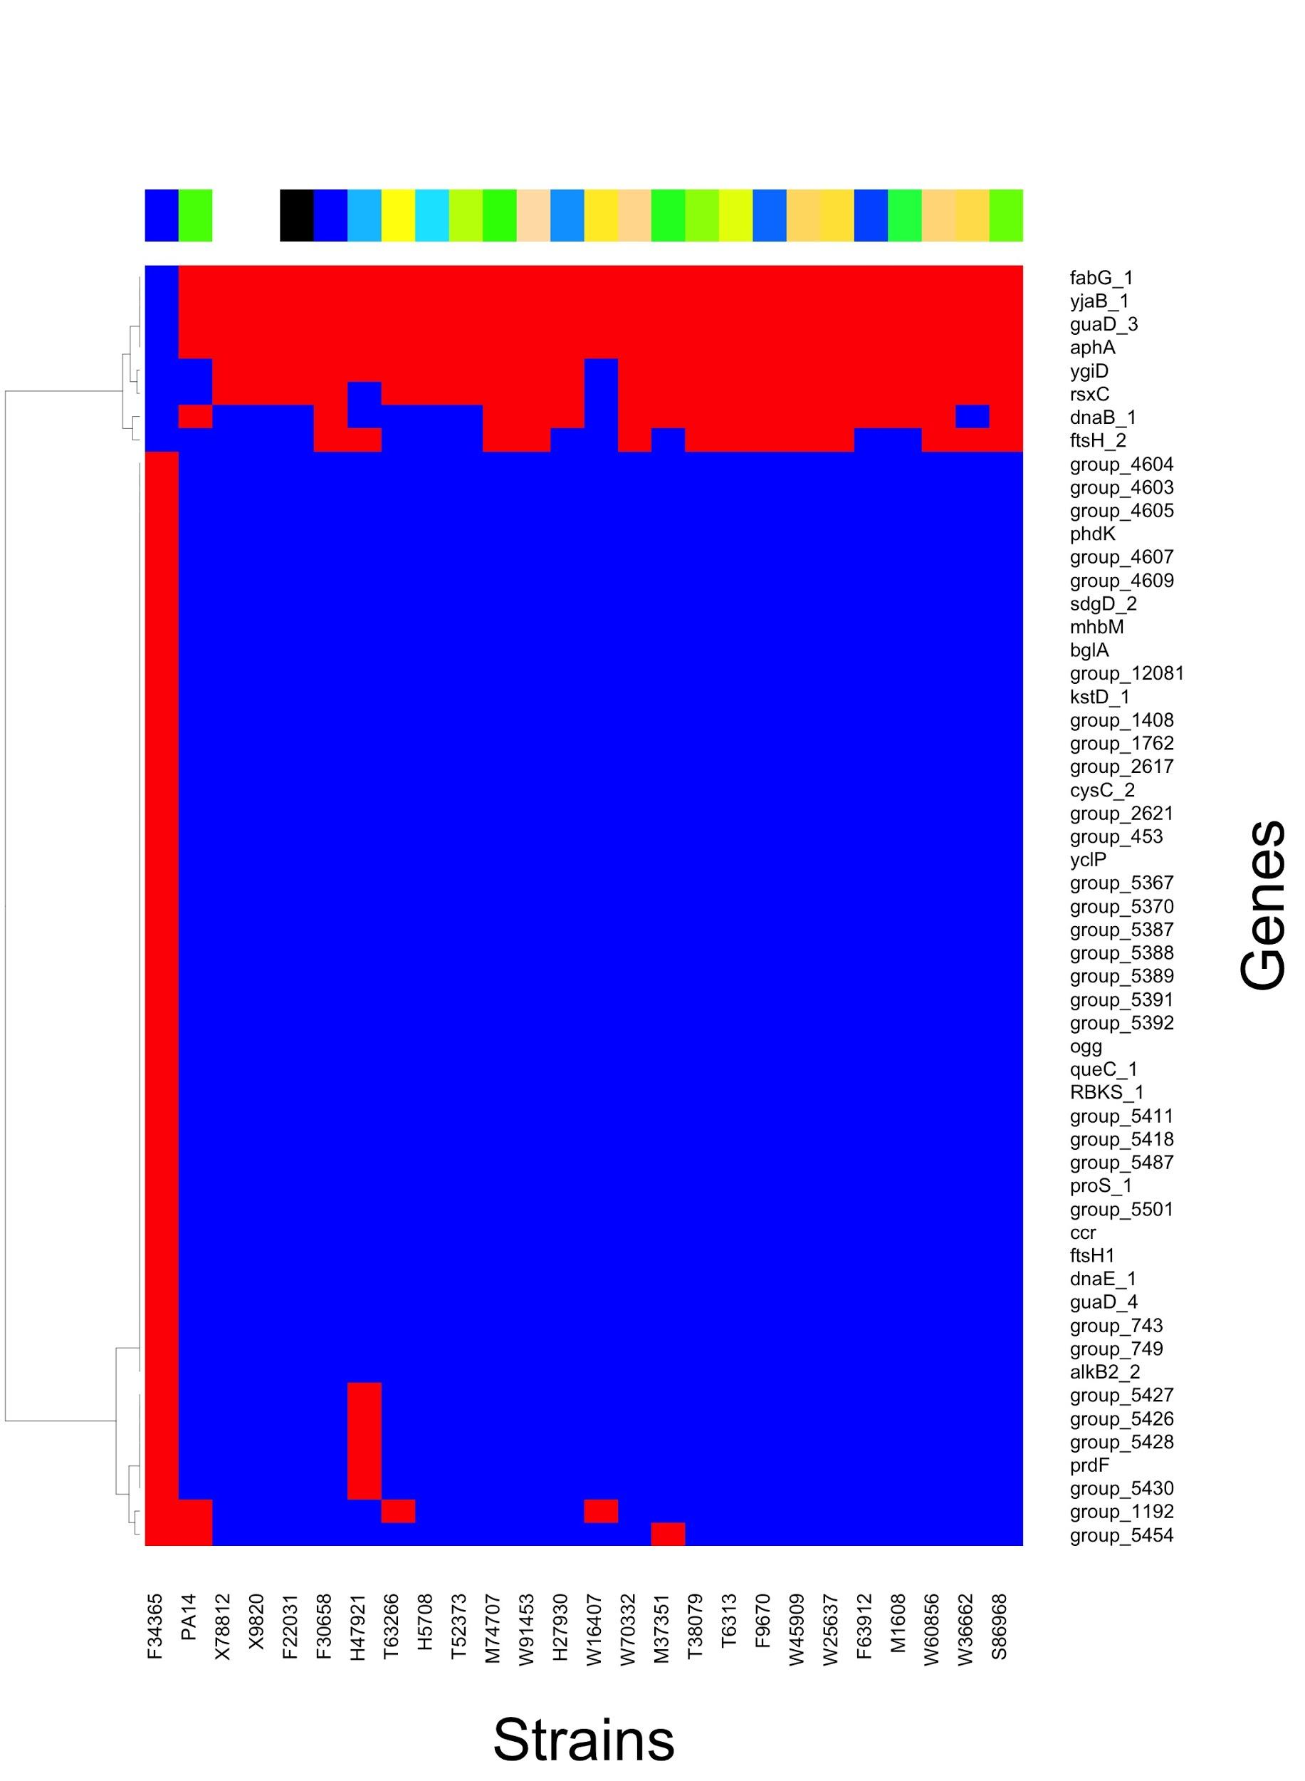

A set of genes that are only present in F34365 (the strain that better swarms) was identified, as well as a smaller set of genes that is present in all the strains except F34365. We did a ORA using the EC numbers of the enzymes these genes code for, and obtained that the enriched pathways were Biosynthesis of secondary metabolites (p-value 3.093502e-08), Biosynthesis of antibiotics (p-value 2.002130e-03), Tyrosine metabolism (p-value 2.255249e-02), Biotin metabolism (p-value 5.501828e-03) and Fatty acid biosynthesis (p-value 3.663958e-03). Being that many of the dompounds related with swarming were involved in aminoacid metabolism, we decided to further examine “Tyrosine metabolism” pathway. 2 enzymes of this pathway appeared as correlated to swarming. The first one was 4-hydroxyphenylacetate 3-monooxygenase oxygenase component (EC 1.4.1.49), and coded by hpaB_2 gene, which in the presence/absence plot is coded as group_453. This gene is only present in F34365. The other enzyme was Gentisate 1,2-dioxygenase (EC 1.13.11.4), coded by SdgD_2 gene. This gene is present in F34365 and F23197, both swarmers. We looked for the overlap between the top compounds related to swarming, according to the OPLS-DA, and the compounds that appear in this pathway. The only one that overlapped was succinate, which is had the highest loading value (is found in higher abundance in non-swarmer strains). This compound is downstream the before mentioned enzymes, so it could be that differences in abundance of this metabolite are due the presence/absence of these 2 genes. 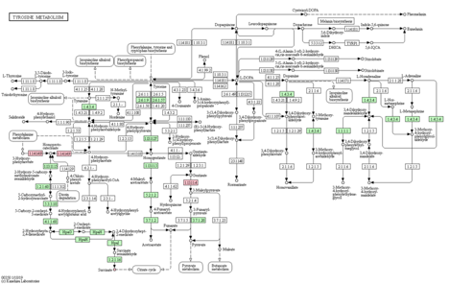

After that we modified the number of groups of genes with extreme loading values we picked: instead of 5 we picked 10, unpacked them and look for the overlap between the EC numbers of the enzymes these genes code for and the enzymes that appear in FELLA graph we obtained with the metabolic pathway enrichment. One enzyme overlapped: Acetolactate synthase isozyme (EC 2.2.1.6), coded by ilvB gene, present in strains F34365, F22031, W16407 (swarmers) and T6313 (non-swarmer). This enzyme participates in many metabolic pathways, but the one that we found most interesting was “Valine, leucine and isoleucine biosynthesis”. 5 compounds in this pathway are highly correlated to swarming (D-erythro-3-Methylmalate, 2-Methyl-maleate, L-Valine, 2-Isopropylmalate and 2-Isopropylmaleate), according to OPLS-DA model, and 3 of them are downstream the enzyme (the 3 last ones). We aligned the gene for the 4 strains and fond that W16407 had a large deletion and that there was only one mutation that had an effect on aminoacid sequence in F34365 (Figure X)

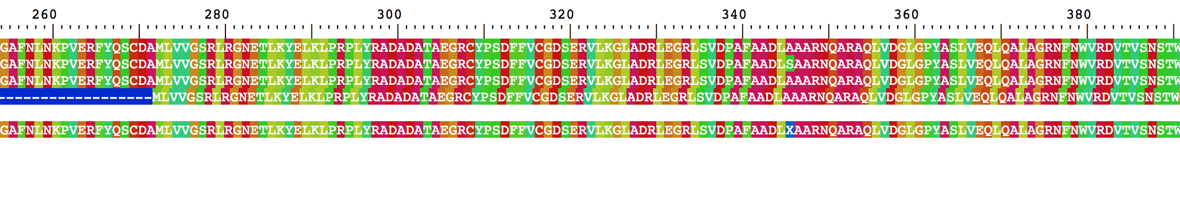

We then clustered the medians of the replicates of the metabolite abundances of these 5 compounds to see if swarmers clustered together. They did not cluster all together, but many of them did, and all aggrupated in the same major cluster.

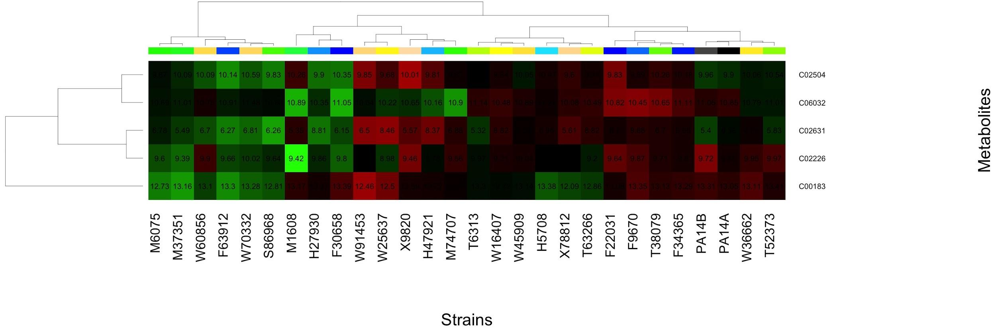

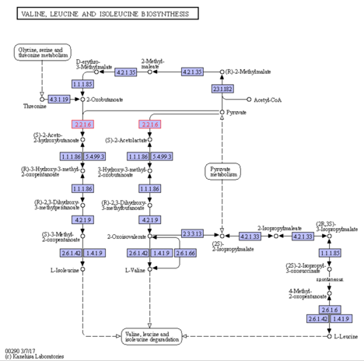

References:

* [1] B. Gyurkocza, A. Rezvani, and R. F. Storb, “Allogeneic hematopoietic cell transplantation: the state of the art.,” *Magn Reson Imaging*, vol. 3, no. 3, pp. 285–299, 2010.
* [2] L. Dethlefsen, S. Huse, M. L. Sogin, and D. A. Relman, “The Pervasive Effects of an Antibiotic on the Human Gut Microbiota , as Revealed by Deep 16S rRNA Sequencing,” *PLoS Biol.*, vol. 6, no. 11, p. e208, 2008.
* [3] Y. Taur *et al.*, “Intestinal domination and the risk of bacteremia in patients undergoing allogeneic hematopoietic stem cell transplantation,” *Clin. Infect. Dis.*, vol. 55, no. 7, pp. 905–914, 2012.
* [4] V. Bucci and J. B. Xavier, “Towards predictive models of the human gut microbiome,” *J. Mol. Biol.*, vol. 426, no. 23, pp. 3907–3916, 2014.
* [5] M. J. van Vliet, H. J. M. Harmsen, E. S. J. M. de Bont, and W. J. E. Tissing, “The role of intestinal microbiota in the development and severity of chemotherapy-induced mucositis,” *PLoS Pathog.*, vol. 6, no. 5, pp. 1–7, 2010.
* [6] A. Safdar and D. Armstrong, “Infectious Morbidity in Critically Ill Patients With Cancer,” *Crit. Care Clin.*, vol. 17, no. 3, pp. 531–570, 2001.
* [7] E. T. Mendes *et al.*, “International Journal of Infectious Diseases Healthcare-associated infection in hematopoietic stem cell transplantation patients : risk factors and impact on outcome,” *Int. J. Infect. Dis.*, vol. 16, no. 6, pp. 424–428, 2012.
* [8] A. D’Souza and C. Fretham, “Current Uses and Outcomes of Hematopoietic Cell Transplantation (HCT): CIBMTR Summary Slides.,” *CIBMTR*, 2017. [Online]. Available: http://www.cibmtr.org.
* [9] M. G. Schuster *et al.*, “Infections in hematopoietic cell transplant recipients: Results from the organ transplant infection project, a multicenter, prospective, cohort study,” *Open Forum Infect. Dis.*, vol. 4, no. 2, pp. 1–7, 2017.
* [10] E. B. El Amari, E. Chamot, R. Auckenthaler, J. C. Pechère, and C. Van Delden, “Influence of previous exposure to antibiotic therapy on the susceptibility pattern of Pseudomonas aeruginosa bacteremic isolates.,” *Clin. Infect. Dis.*, vol. 33, no. 11, pp. 1859–1864, 2001.
* [11] F. Vuotto *et al.*, “Risk factors, clinical features, and outcome of Pseudomonas aeruginosa bacteremia in patients with hematologic malignancies: A case-control study,” *Am. J. Infect. Control*, vol. 41, no. 6, pp. 527– 530, 2013.
* [12] P. Markou and Y. Apidianakis, “Pathogenesis of intestinal Pseudomonas aeruginosa infection in patients with cancer,” *Front. Cell. Infect. Microbiol.*, vol. 3, no. January, pp. 1–5, 2013.
* [13] C. Coulon, E. Vinogradov, A. Filloux, and I. Sadovskaya, “Chemical Analysis of Cellular and Extracellular Carbohydrates of a Biofilm-Forming Strain Pseudomonas aeruginosa PA14,” *PLoS One*, vol. 5, no. 12, p. e142220, 2010.
* [14] F. Al-wrafy, E. Brzozowska, S. Górska, and A. Gamian, “Pathogenic factors of Pseudomonas aeruginosa – the role of biofilm in pathogenicity and as a target for phage therapy,” *Postepy Hig. Med. Dosw.*, vol. 71, no. 0, pp. 78–91, 2017.
* [15] O. Zaborina *et al.*, “Identification of multi-drug resistant Pseudomonas aeruginosa clinical isolates that are highly disruptive to the intestinal epithelial barrier,” *Ann. Clin. Microbiol. Antimicrob.*, vol. 5, no. 14, pp. 1–10, 2006.
* [16] J. Alverdy, C. Holbrook, F. Rocha, L. Seiden, M. Musch, and S. Suh, “Gut-Derived Sepsis Occurs When the Right Pathogen With the Right Virulence Genes Meets the Right Host: Evidence for In Vivo Virulence Expression in Pseudomonas,” *Ann. Surg.*, vol. 232, no. 4, pp. 480–489, 2000.
* [17] J. Okuda *et al.*, “Translocation of Pseudomonas aeruginosa from the Intestinal Tract Is Mediated by the Binding of ExoS to an Na,K-ATPase Regulator, FXYD3,” *Infect. Immun.*, vol. 78, no. 11, pp. 4511–4522, 2010.
* [18] J. Overhage, M. Bains, M. D. Brazas, and R. E. W. Hancock, “Swarming of Pseudomonas aeruginosa is a complex adaptation leading to increased production of virulence factors and antibiotic resistance,” *J. Bacteriol.*, vol. 190, no. 8, pp. 2671–2679, 2008.
* van Ditmarsch D, Boyle KE, Sakhtah H, Oyler JE, Nadell CD, et al. (2013) Convergent Evolution of Hyperswarming Leads to Impaired Biofilm Formation in Pathogenic Bacteria. Cell Reports 4: 697–708.
* Murray TS, Ledizet M, Kazmierczak BI (2010) Swarming motility, secretion of type 3 effectors and bio- film formation phenotypes exhibited within a large cohort of Pseudomonas aeruginosa clinical isolates. Journal of medical microbiology 59: 511–520. https://doi.org/10.1099/jmm.0.017715-0 PMID: 20093376
* [19] U. Roessner and J. Bowne, “What is metabolomics all about ?,” *Biotechniques*, vol. 46, no. 5, pp. 363–365, 2009.
* [20] O. Fiehn, “Metabolomics – the link between genotypes and phenotypes,” *Plant Mol. Biol.*, vol. 48, no. 1–2, pp. 25

**References**

Abdel-Mawgoud, A.M., Lépine, F. and Déziel, E. 2010. Rhamnolipids: diversity of structures, microbial origins and roles. *Applied Microbiology and Biotechnology* 86(5), pp. 1323–1336.

Biro, P.A. and Stamps, J.A. 2010. Do consistent individual differences in metabolic rate promote consistent individual differences in behavior? *Trends in Ecology & Evolution* 25(11), pp. 653–659.

Boyle, K.E., Monaco, H., van Ditmarsch, D., Deforet, M. and Xavier, J.B. 2015. Integration of metabolic and quorum sensing signals governing the decision to cooperate in a bacterial social trait. *PLoS Computational Biology* 11(5), p. e1004279.

Boyle, K.E., Monaco, H.T., Deforet, M., et al. 2017. Metabolism and the evolution of social behavior. *Molecular Biology and Evolution* 34(9), pp. 2367–2379.

Bru, J.-L., Rawson, B., Trinh, C., Whiteson, K., Høyland-Kroghsbo, N.M. and Siryaporn, A. 2019. PQS Produced by the Pseudomonas aeruginosa Stress Response Repels Swarms Away from Bacteriophage and Antibiotics. *Journal of Bacteriology* 201(23).

Chen, C.Y., Baker, S.C. and Darton, R.C. 2007. The application of a high throughput analysis method for the screening of potential biosurfactants from natural sources. *Journal of Microbiological Methods*.

Chong, H. and Li, Q. 2017. Microbial production of rhamnolipids: opportunities, challenges and strategies. *Microbial Cell Factories* 16(1), p. 137.

Deforet, M., van Ditmarsch, D., Carmona-Fontaine, C. and Xavier, J.B. 2014. Hyperswarming adaptations in a bacterium improve collective motility without enhancing single cell motility. *Soft matter* 10(14), pp. 2405–2413.

van Ditmarsch, D., Boyle, K.E., Sakhtah, H., et al. 2013. Convergent evolution of hyperswarming leads to impaired biofilm formation in pathogenic bacteria. *Cell reports* 4(4), pp. 697–708.

Inoue, T., Shingaki, R., Hirose, S., Waki, K., Mori, H. and Fukui, K. 2007. Genome-wide screening of genes required for swarming motility in Escherichia coli K-12. *Journal of Bacteriology* 189(3), pp. 950–957.

Jain, D.K. and Collins, D.L. A drop-collapsing test for screening surfactant-producing microorganisms. *Thompson*.

Kearns, D.B. 2010. A field guide to bacterial swarming motility. *Nature Reviews. Microbiology* 8(9), pp. 634–644.

Kim, W. and Surette, M.G. 2004. Metabolic differentiation in actively swarming Salmonella. *Molecular Microbiology* 54(3), pp. 702–714.

Klevens, R.M., Edwards, J.R., Richards, C.L., et al. 2007. Estimating health care-associated infections and deaths in U.S. hospitals, 2002. *Public health reports (Washington, D.C. : 1974)* 122(2), pp. 160–166.

Köhler, T., Curty, L.K., Barja, F., van Delden, C. and Pechère, J.C. 2000. Swarming of *Pseudomonas aeruginosa* is dependent on cell-to-cell signaling and requires flagella and pili. *Journal of Bacteriology* 182(21), pp. 5990–5996.

Mattingly, A.E., Kamatkar, N.G., Borlee, B.R. and Shrout, J.D. 2018. Multiple Environmental Factors Influence the Importance of the Phosphodiesterase DipA upon *Pseudomonas aeruginosa* Swarming. *Applied and Environmental Microbiology* 84(7).

Medina, G., Juárez, K., Valderrama, B. and Soberón-Chávez, G. 2003. Mechanism of Pseudomonas aeruginosa RhlR transcriptional regulation of the rhlAB promoter. *Journal of Bacteriology* 185(20), pp. 5976–5983.

Mellbye, B. and Schuster, M. 2014. Physiological framework for the regulation of quorum sensing-dependent public goods in Pseudomonas aeruginosa. *Journal of Bacteriology* 196(6), pp. 1155–1164.

Overhage, J., Bains, M., Brazas, M.D. and Hancock, R.E.W. 2008. Swarming of Pseudomonas aeruginosa is a complex adaptation leading to increased production of virulence factors and antibiotic resistance. *Journal of Bacteriology* 190(8), pp. 2671–2679.

Smith, E. and Morowitz, H.J. 2004. Universality in intermediary metabolism. *Proceedings of the National Academy of Sciences of the United States of America* 101(36), pp. 13168–13173.

Thévenot, E.A., Roux, A., Xu, Y., Ezan, E. and Junot, C. 2015. Analysis of the Human Adult Urinary Metabolome Variations with Age, Body Mass Index, and Gender by Implementing a Comprehensive Workflow for Univariate and OPLS Statistical Analyses. *Journal of Proteome Research* 14(8), pp. 3322–3335.

Tremblay, J. and Déziel, E. 2010. Gene expression in Pseudomonas aeruginosa swarming motility. *BMC Genomics* 11, p. 587.

Wang, Q., Frye, J.G., McClelland, M. and Harshey, R.M. 2004. Gene expression patterns during swarming in Salmonella typhimurium: genes specific to surface growth and putative new motility and pathogenicity genes. *Molecular Microbiology* 52(1), pp. 169–187.

Xavier, J.B., Kim, W. and Foster, K.R. 2011. A molecular mechanism that stabilizes cooperative secretions in *Pseudomonas aeruginosa*. *Molecular Microbiology* 79(1), pp. 166–179.

Yan, J., Deforet, M., Boyle, K.E., et al. 2017. Bow-tie signaling in c-di-GMP: Machine learning in a simple biochemical network. *PLoS Computational Biology* 13(8), p. e1005677.

Yan, J., Estanbouli, H., Liao, C., et al. 2019. Systems-level analysis of NalD mutation, a recurrent driver of rapid drug resistance in acute Pseudomonas aeruginosa infection. *PLoS Computational Biology* 15(12), p. e1007562.

Yeung, A.T.Y., Bains, M. and Hancock, R.E.W. 2011. The sensor kinase CbrA is a global regulator that modulates metabolism, virulence, and antibiotic resistance in *Pseudomonas aeruginosa.* *Journal of Bacteriology* 193(4), pp. 918–931.

Zhu, K. and Rock, C.O. 2008. RhlA converts beta-hydroxyacyl-acyl carrier protein intermediates in fatty acid synthesis to the beta-hydroxydecanoyl-beta-hydroxydecanoate component of rhamnolipids in *Pseudomonas aeruginosa.* *Journal of Bacteriology* 190(9), pp. 3147–3154.

**Figures**

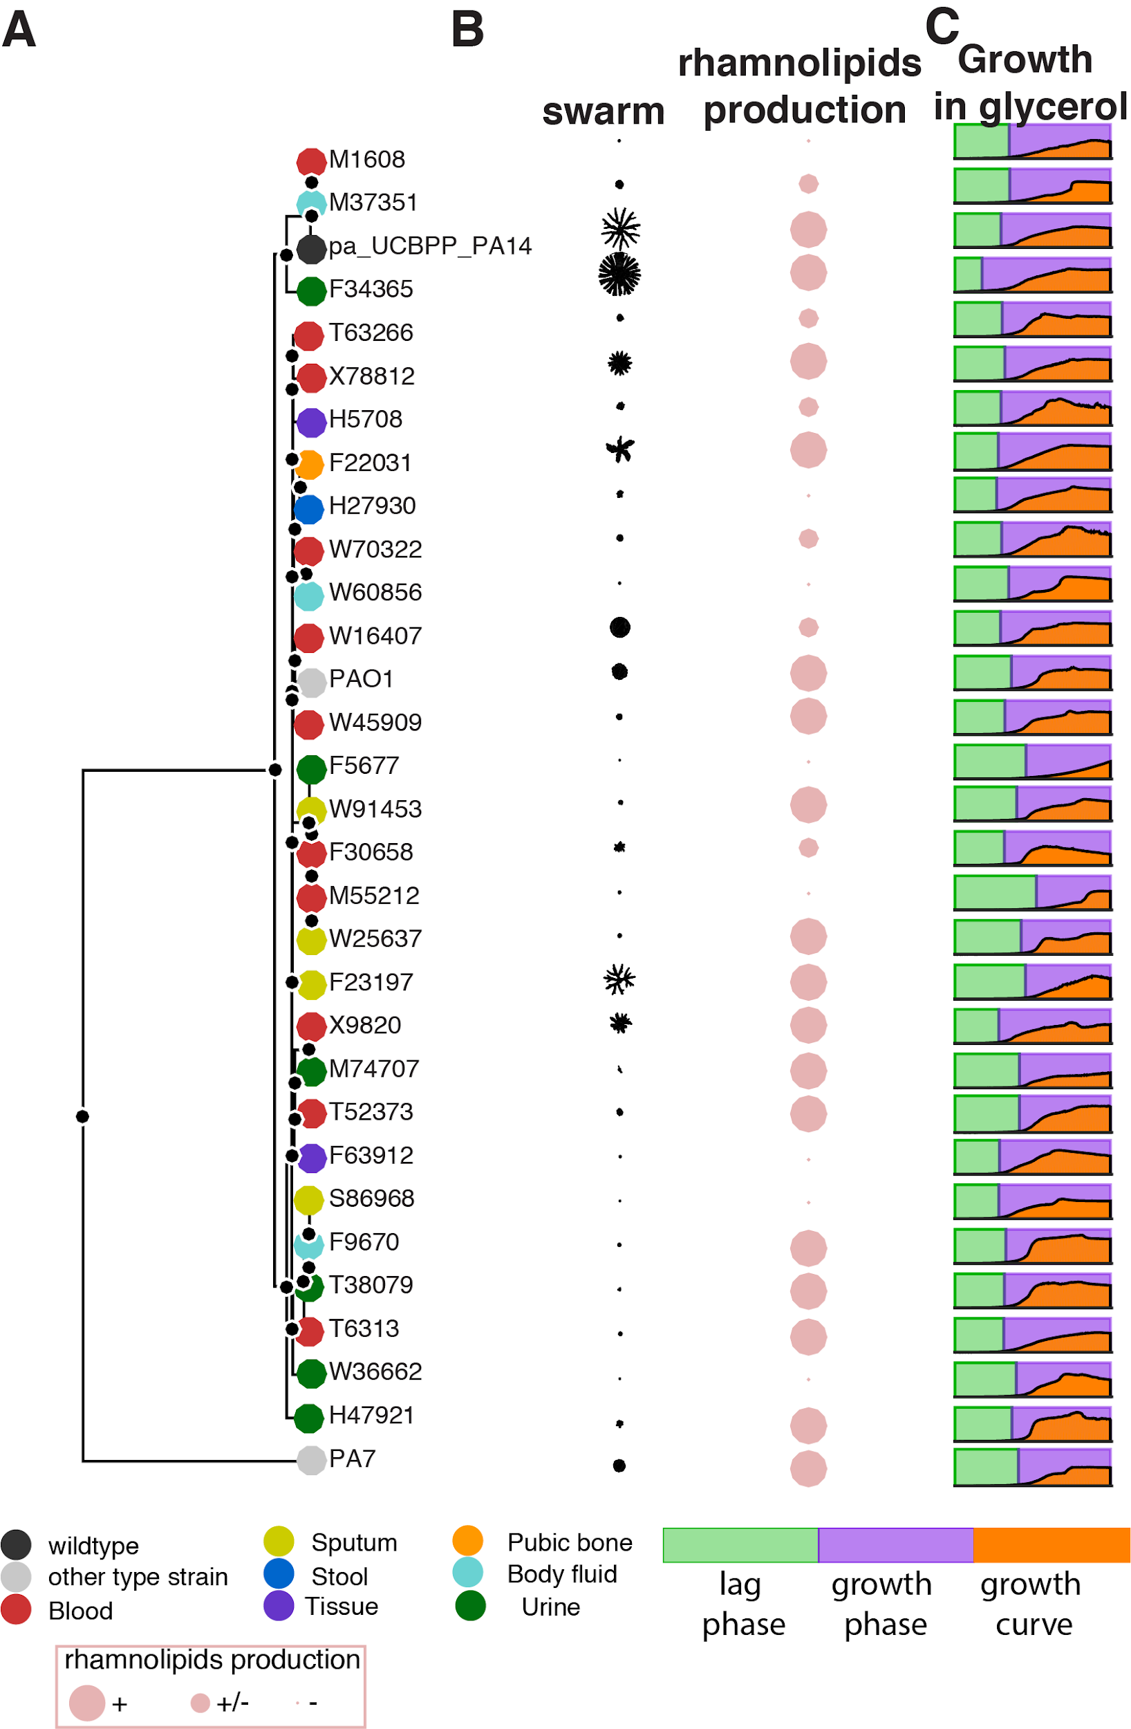

**Figure 1.** Diversity of swarming across the *P. aeruginosa* phylogeny. **A.** Phylogeny of clinical isolates obtained from patients with cancer at MSKCC (Yan et al. 2017; Yan et al. 2019) together with reference strains PAO1, PA14 and PA7. The tissue of origin of each patient isolate is also shown. **B**. The ability to swarm (swarming picture shown) does not correlate with phylogeny; however, all swarmers can secrete rhamnolipids. They also tend to have a shorter lag phase in a minimal growth medium using glycerol as the sole carbon source, suggesting that the link between metabolic capability and swarming which we observed in the PA14 background (Boyle et al. 2017) may be conserved across the phylogenetic tree.

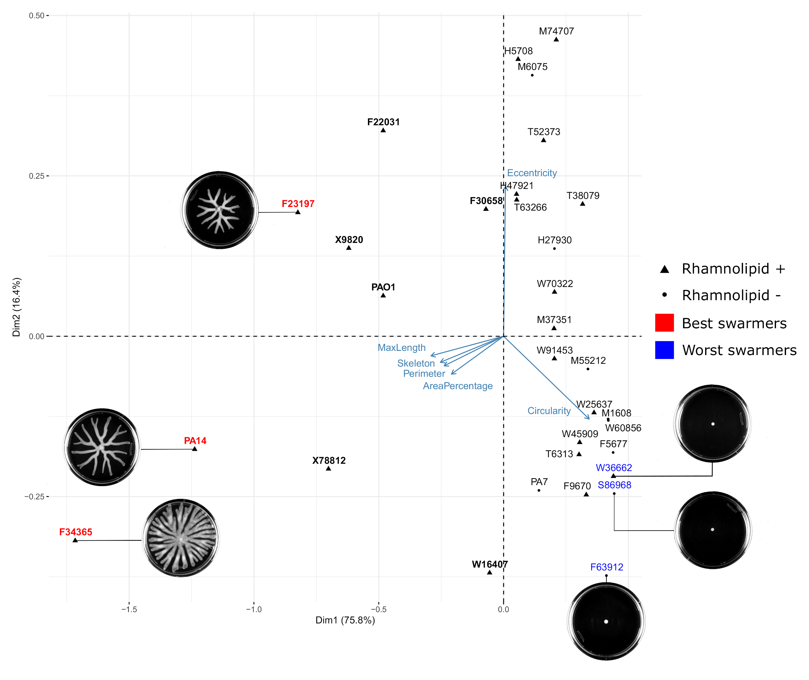

**Figure S1:** Quantitative analysis of the swarming phenotype. **A**. We imaged swarming colonies grown overnight growth at 37ºC in soft-agar casamino acids plates. Roughly it is possible to identify swarmers by simple observation: the strains in bold). With the aim of getting a quantitative measure of swarming, we tested different morphological features of the colony using computational image analysis: maximum length (larger diagonal of the rectangle fitting the colony), skeleton, perimeter, area of the colony, area percentage (percentage of the plate occupied by the colony), circularity and eccentricity. Many of these features are correlated, so we used a principal component analysis to identify features that explained the majority variation among the strains, shown in the biplot presented here. *Max. length* and *circularity* were the two features that better separated the strains according to swarming. The top 3 strains with largest and shortest colonies (best swarmers and non swarmers), determined by eye, are highlighted in red and blue and the picture of their swarm is shown. Rhamnolipid production is also indicated.

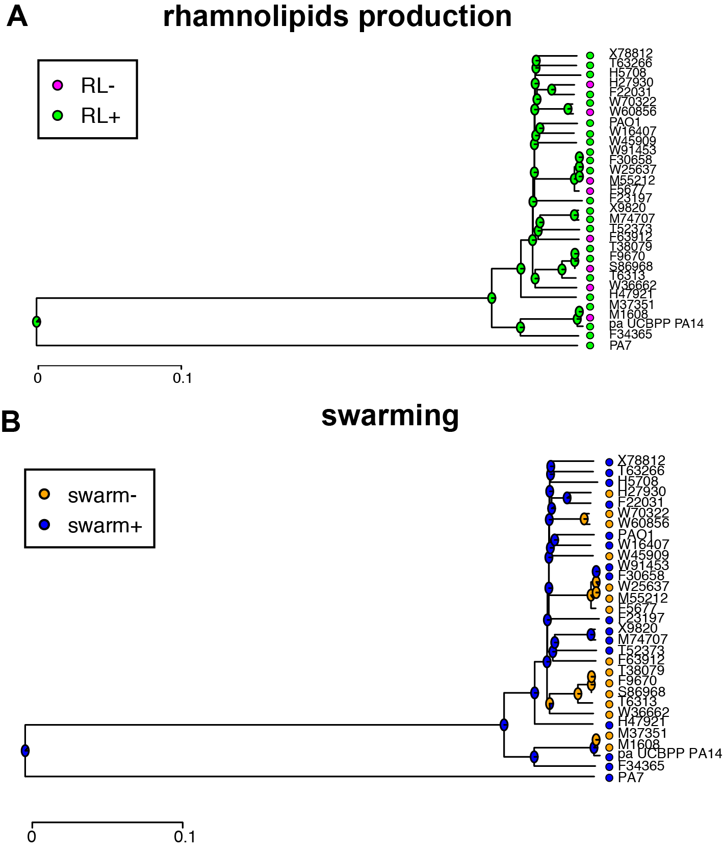

**Figure S2** Phylogenetic reconstruction of rhamnolipids production (A) and swarming phenotype (B). The pie chart in the nodes of branches indicate the likelihood of the phenotype for each ancestral state.

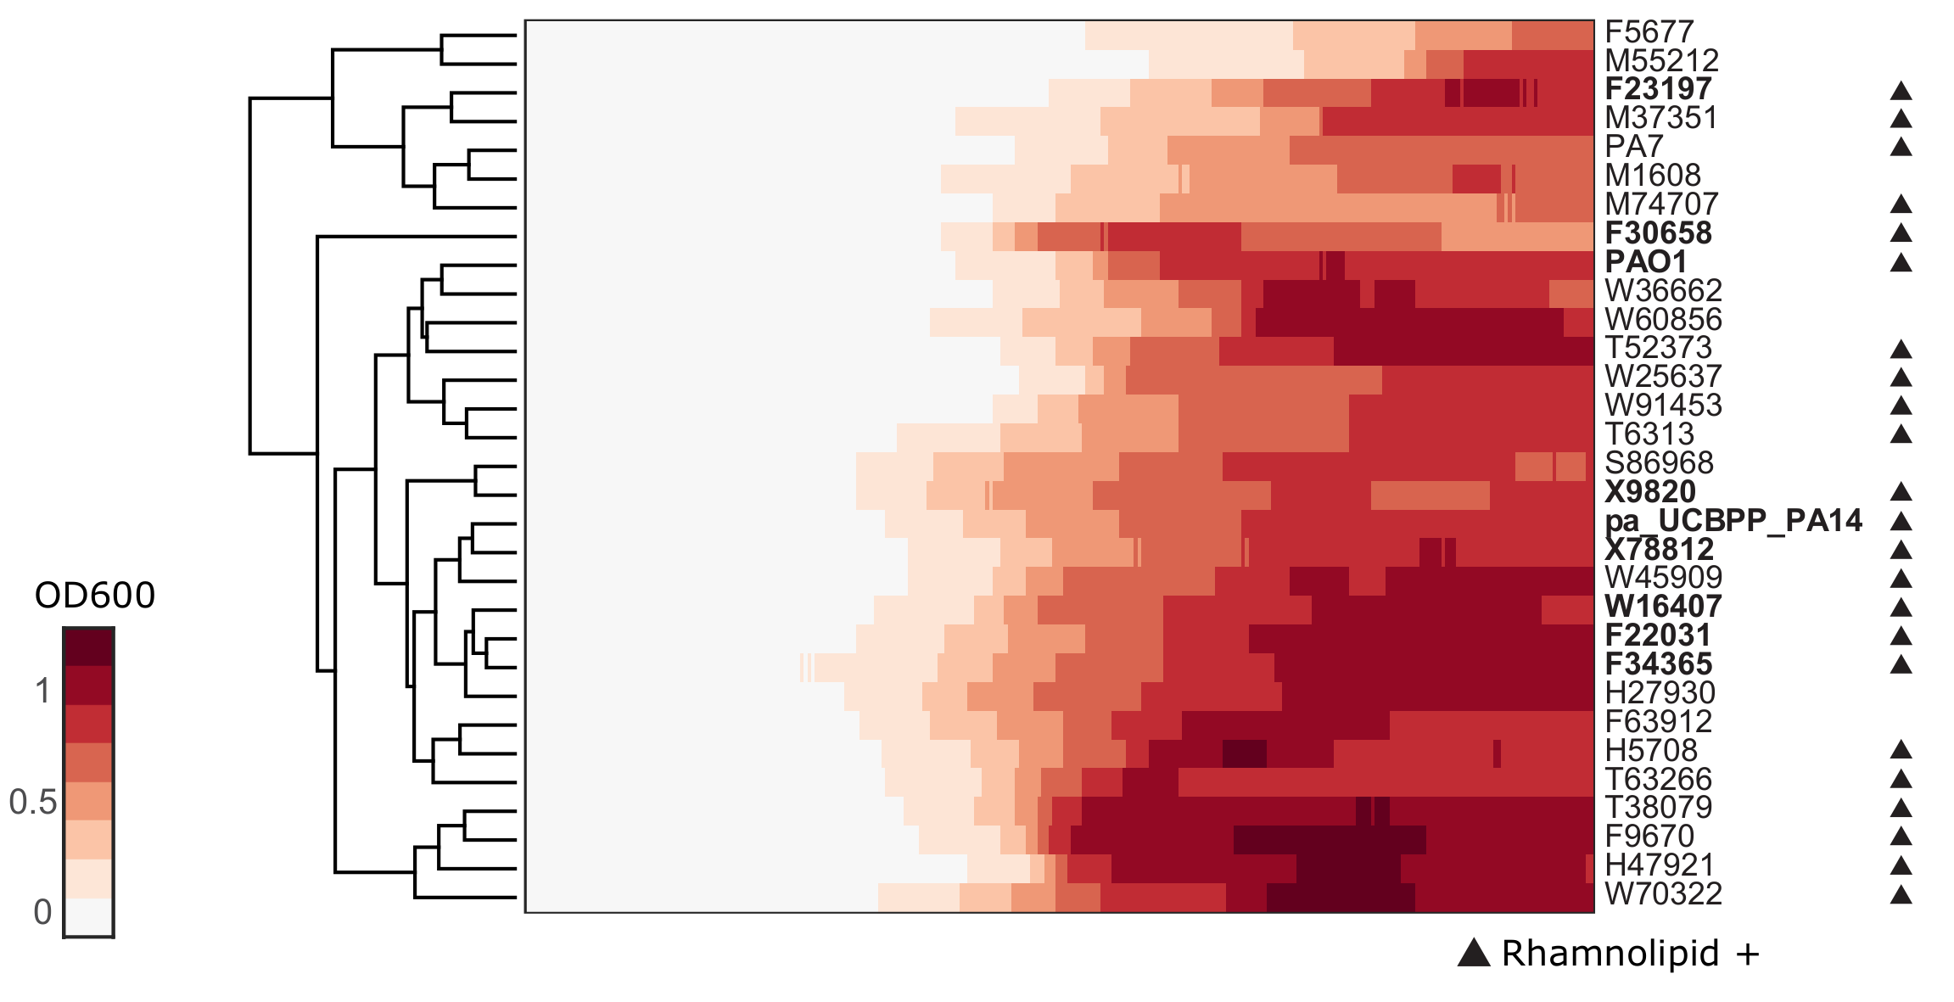

**Figure S3** Clustergram of growth curve in glycerol of *P. aeruginosa* isolates. The clinical isolates along with type strains PA14, PAO1 and PA7 were grown in the same synthetic medium of metabolomics extraction (with glycerol as sole carbon source) at 37ºC for 48 h (initial OD600 was 0.0025). The growths curves were determined by measuring OD600 each 10 minutes. The growth curves were clustered using Euclidean distance. The strains that by simple observation are swarmers are indicated in bold. Most of the swarmers are aggregated together, with the exception of F30658 and PAO1, which are both mild swarmers, and F23197, which has a longer lag phase in comparison to the rest of the isolates.

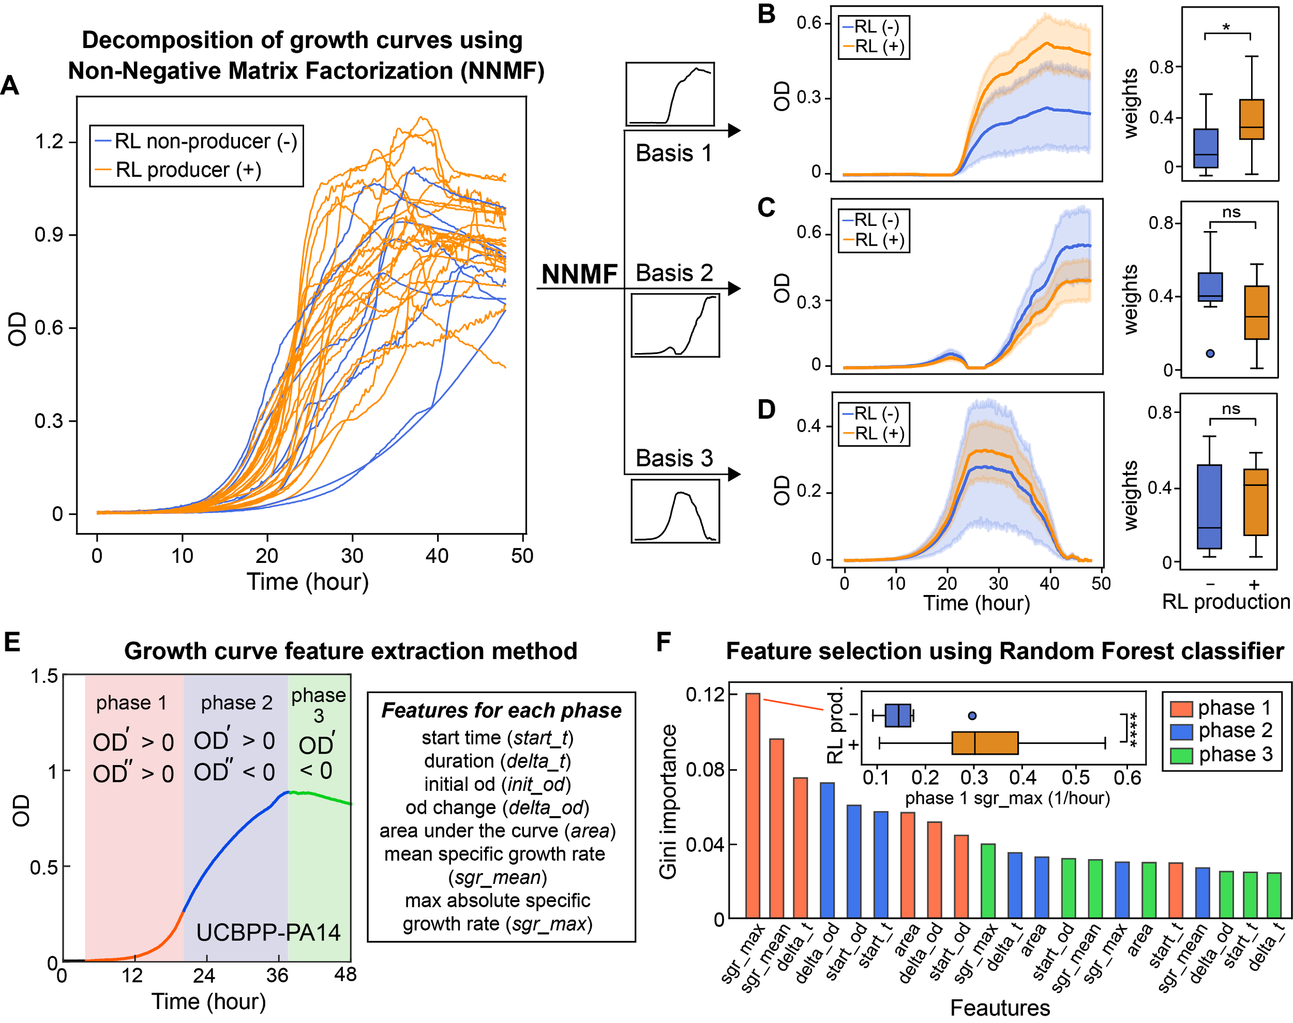

**Figure 2** Growth curve features distinguish rhamnolipid producers from non-producers. (**A-D**) Unsupervised feature selection using non-negative matrix factorization (NNMF), which decomposes growth curves of all *Pseudomonas* isolates into three additive basis functions (features) such that each growth curve can be approximately represented by the weighted sum of these functions. (**A**) Growth curves from both rhamnolipid producers (orange) and non-producers (blue). (**B-D**) Decomposed components (basis function multiplied by weights; left panels) and weights (right panels) from NNMF grouped by rhamnolipid (RL) production. The shaded areas represent 95% bootstrap confidence interval of the mean. (**E**, **F**) Supervised feature selection using Random Forest classifier. (**E**) Feature extraction method. Each growth curve (excluding the initial lag phase) was divided into three phases (left panel) and each phase was described by 7 quantitative features (right panel). (**F**) Ranking of feature importance in classifying rhamnolipid producers. Inset: boxplot of maximum specific growth rate of phase 1 grouped by rhamnolipid production. Welch’s t-test was used in (**B-D**) and (**F**) for significance testing. ****, p-value $≤$ 0.0001; *, p-value $≤$ 0.05; ns, p-value > 0.05.